 

# MEENAKSHI SUNDARARAJAN ENGINEERING COLLEGE

**Kodambakkam, Chennai-600024.**

**DEPARTMENT OF INFORMATION TECHNOLOGY**

**TOPIC: LEVERAGING DATA ANALYTICS FOR OPTIMAL CAMPAIGN SUCCESS**

**Performance TEAM ID :** NM2023TMID07243 **FACULTY MENTOR :** R**.**Nandha kumari **INDUSTRY MENTOR :** Shivam Shivhare

**Project submitted by:**

|  |  |  |
| --- | --- | --- |
| **TEAM** | **NAME** | **REG .NO.** |
| Team Leader | TEYJUSWINI M | 311520205049 |
| Team Member 1 | ABHINAYA PREMCHAND | 311520205002 |
| Team Member 2 | KAVITHA | 311520205018 |
| Team Member 3 | RITHIK HARENDAR M | 311520205038 |

**TABLE OF CONTENTS**

## INTRODUCTION

* 1. Project Overview
  2. Purpose

## LITERATURE SURVEY

* 1. Existing problem
  2. References
  3. Problem Statement Definition

## IDEATION & PROPOSED SOLUTION

* 1. Empathy Map Canvas
  2. Ideation & Brainstorming

## REQUIREMENT ANALYSIS

* 1. Functional requirement
  2. Non-Functional requirements

## PROJECT DESIGN

* 1. Data Flow Diagrams & User Stories
  2. Solution Architecture

## PROJECT PLANNING & SCHEDULING

* 1. Technical Architecture
  2. Sprint Planning & Estimation
  3. Sprint Delivery Schedule

## CODING & SOLUTIONING

* 1. Feature 1
  2. Feature 2
  3. Database Schema (if Applicable)

## PERFORMANCE TESTING

* 1. Performance Metrics

## RESULTS

* 1. Output Screenshots

## ADVANTAGES & DISADVANTAGES

1. **CONCLUSION**

## FUTURE SCOPE

1. **APPENDIX**

## Source Code

**GitHub & Project Demo Link**

## ABSTRACT

In the dynamic landscape of modern business, the effectiveness of marketing campaigns hinges on data-driven decision-making. This project is driven by the imperative to harness the power of data analysis to optimize marketing efforts. The project objectives encompass transforming marketing decisions from intuition to data-backed insights, segmenting audiences based on demographics and preferences, and continuously refining campaigns to adapt to market dynamics. Personalization and cost efficiency are paramount, ensuring a more engaging and relevant customer experience while optimizing budgets. Key performance indicators (KPIs) play a pivotal role in assessing marketing effectiveness and enabling realtime strategy adjustments. The methodology involves collecting data from various sources, utilizing statistical and machine learning techniques for data analysis, creating audience profiles, and conducting A/B testing for campaign assessment. The iterative approach ensures campaigns evolve in response to changing market conditions and audience preferences. This research marks a significant step towards achieving marketing success in an

increasingly data-centric business world.

## CHAPTER 1 INTRODUCTION

In today's fast-paced and data-driven business landscape, the key to achieving optimal marketing campaign success lies in the strategic utilization of data analysis. Gone are the days when marketing decisions were based on intuition or guesswork; now, organizations harness the power of data to gain valuable insights into consumer behavior, preferences, and market trends. Leveraging data analysis has become a fundamental pillar of modern marketing strategies, enabling businesses to fine-tune their campaigns, maximize return on investment, and deliver precisely tailored messages to their target audience. This introduction explores the critical role data analysis plays in shaping marketing campaigns for success and outlines the transformative potential it holds for businesses striving to remain competitive in an increasingly data-centric world.

## PROJECT OVERVIEW

This project focuses on harnessing the power of data analysis to enhance the success of marketing campaigns. In the modern businesslandscape, data-driven decision-making is essential for achieving thebest results.

## PROJECT OBJECTIVE / PURPOSE

* + - Data-Driven Decision Making**:**

Utilize data analysis to shift marketing decisions from intuition to data-backed insights, enhancing the overall effectivenessof campaigns.

* + - Audience Segmentation**:**

Employ data analysis to segment the audience into distinct groups based on demographics, behavior, and preferences, tailoring marketing efforts accordingly.

* + - Campaign Optimization**:**

Continuously monitor and refine marketing campaigns through data analysis,

ensuring they perform at their peak and adapt to changing market dynamics.

* + - Personalization**:**

Implement personalized marketing strategies by analyzing customer data, creating a more engaging and relevant experience forthe audience.

* + - Cost Efficiency**:**

Optimize marketing budgets by identifying high- performing channels and strategies, reducing wastage and maximizing ROI.

* + - Performance Metrics**:**

Develop key performance indicators (KPIs) to assess the effectiveness of marketing efforts and adjust strategies in real-time.

## PROJECT METHODOLOGY

* + - Data Collection**:**

Gather data from various sources, including customer interactions, website analytics, social media, and email campaigns.

* + - Data Analysis**:**

Employ statistical and machine learning techniques to extract valuable insights from the collected data, identifying trends, patterns,and correlations.

* + - Audience Profiling**:**

Create detailed customer profiles, categorizing them based on demographics, behavior, and preferences.

* + - Campaign Testing**:**

A/B testing and other experiments to assess the impact of data- driven changes on marketing campaigns.

* + - Iterative Optimization**:**

Continuously refine marketing campaigns based on data analysis and feedback, adapting to market shifts and audience preferences.

# CHAPTER 2 LITERATURE SURVEY

A literature survey for "Leveraging Data Analysis for Optimal Marketing Campaign Success" would involve reviewing academic research, industry reports, and scholarly articles to gain a comprehensive understanding of the subject. Below are some key themes and references that can be explored in such a survey

## Data-Driven Marketing Strategies:

* 1. Chaffey, D., & Ellis-Chadwick, F. (2019). Digital marketing: Strategy, implementation, and practice. Pearson UK.
  2. Davenport, T. H., Harris, J., & Shapiro, J. (2010). Competing on analytics: The new science of winning. Harvard Business Press.

## Customer Segmentation and Personalization:

1. Kumar, V., & Rajan, B. (2019). Data science for business: What you need to know about data mining and data-analytic thinking. Columbia University Press.
2. Verhoef, P. C., & Leeflang, P. S. (2009). Understanding the marketing department’s influence within the firm. Journal of Marketing, 73(2), 14-37.

## Marketing Analytics Tools and Techniques:

1. Farris, P. W., Bendle, N. T., Pfeifer, P. E., & Reibstein, D. J. (2010). Marketing metrics: The definitive guide to measuring marketing performance. Pearson UK.
2. Provost, F., & Fawcett, T. (2013). Data science for business: What you need to know about data mining and data-analytic thinking. O'Reilly Media.

## Real-time Marketing and Campaign Optimization:

1. McAfee, A., & Brynjolfsson, E. (2012). Big data: The management revolution. Harvard Business Review, 90(10), 60-68.
2. Wang, D., Sun, B., & Wang, X. (2014). Tweeting for learning: A critical analysis of research on microblogging in education published in 2008-2011. British Journal of Educational Technology, 45(5), 809-817.

## Data-Driven Culture and Organizational Change:

1. Ross, J. W., Beath, C., & Goodhue, D. L. (1996). Develop long-term competitiveness through IT assets. Sloan Management Review, 38(1), 31-42.
2. Brynjolfsson, E., & McAfee, A. (2014). The second machine age: Work, progress, and prosperity in a time of brilliant technologies. W. W. Norton & Company.

## Key Performance Indicators (KPIs) and Marketing Effectiveness:

1. Moorman, C., & Rust, R. T. (1999). The role of marketing. Journal of Marketing, 63, 180-197.
2. Lehmann, D. R., & Winer, R. S. (2007). Analysis for marketing planning. McGraw-Hill/Irwin.

## Case Studies and Industry Reports:

1. Various industry-specific reports and case studies can provide practical insights into how organizations have successfully leveraged data analysis for marketing campaign success.

This literature survey will provide a solid foundation for understanding the principles, methodologies, and best practices associated with leveraging data analysis for optimal marketing campaign success, and it will help in identifying gaps or emerging trends in the field.

# EXISTING PROBLEM

* Data Quality and Integration:

Inconsistent, inaccurate, or incomplete data from various sources can hinder effective analysis. Integrating data from multiple channels and ensuring its quality is a persistent challenge.

* Privacy and Compliance:

The growing concerns about data privacy, along with regulations like GDPR and CCPA, make it challenging to collect and use customer data for marketing analysis without violating regulations.

* Data Overload:

Organizations often struggle with managing the sheer volume of data available. Processing, analyzing, and deriving actionable insights from big data can be overwhelming.

* Talent Shortage:

Finding skilled data analysts, data scientists, and marketing professionals who understand both data and marketing is a challenge. There's a shortage of professionals with the necessary skill sets.

* Technological Infrastructure:

Outdated or inadequate technology infrastructure can limit an organization's ability to perform advanced data analysis. Implementing new tools and systems can be costly and complex.

* Real-time Analysis:

Achieving real-time data analysis to respond swiftly to market changes is a

challenge for many businesses. Delays in data processing and decision-making can impact campaign effectiveness.

* Attribution Modeling:

Accurately attributing conversions to specific marketing touchpoints in the customer journey is often complex and contentious. Many organizations struggle with assigning the right credit to each touchpoint.

* Measuring Offline and Online Interactions:

For businesses that operate in both online and offline realms, tracking and analyzing customer interactions across these channels and attributing their impact accurately can be challenging.

* Testing and Experimentation:

Conducting A/B tests and experiments to refine marketing strategies requires careful planning, and results can be influenced by various factors, making it challenging to draw definitive conclusions.

* Resistance to Change:

Organizations often face resistance to adopting a data- driven culture. Traditional marketing approaches and reluctance to trust data over intuition can hinder progress.

* Costs:

Implementing and maintaining data analysis tools and hiring skilled professionals can be expensive. Smaller businesses may find it challenging to invest in these resources.

* Data Security:

Protecting customer data from breaches and cyber threats is crucial. Organizations must invest in robust security measures to safeguard customer information.

* Interpreting Data:

While data analysis provides insights, interpreting those insights correctly and turning them into actionable strategies is a skill that organizations must continually develop

# REFERENCES

## Books:

* Chaffey, D., & Ellis-Chadwick, F. (2019). "Digital Marketing: Strategy, Implementation, and Practice." Pearson UK.
* Kumar, V., & Rajan, B. (2019). "Data Science for Business: What You Need to Know about Data Mining and Data-Analytic Thinking." Columbia University Press.
* Farris, P. W., Bendle, N. T., Pfeifer, P. E., & Reibstein, D. J. (2010). "Marketing Metrics: The Definitive Guide to Measuring Marketing Performance." Pearson UK.
* Provost, F., & Fawcett, T. (2013). "Data Science for Business: What You Need to Know about Data Mining and Data-Analytic Thinking." O'Reilly Media.

## Articles:

* + Davenport, T. H., Harris, J., & Shapiro, J. (2010). "Competing on Analytics: The New Science of Winning." Harvard Business Review.
  + McAfee, A., & Brynjolfsson, E. (2012). "Big Data: The Management Revolution." Harvard Business Review, 90(10), 60-68.
  + Brynjolfsson, E., & McAfee, A. (2014). "The Second Machine Age: Work, Progress, and Prosperity in a Time of Brilliant Technologies." W. W. Norton & Company.

## Reports and Case Studies:

Various industry-specific reports and case studies from marketing organizations and consulting firms can provide real-world examples of how data analysis is being used for marketing success.

# CHAPTER 3

**IDEATION & PROPOSED SOLUTION**

1. Enhancing Data Quality:

Implement data validation and cleansing processes, regularly audit data sources, and utilize data integration tools to ensure high-quality data.

1. Privacy and Compliance:

Develop transparent data usage policies, acquire explicit customer consent for data collection, and utilize compliance management platforms to adhere to regulations.

1. Talent Shortage:

Invest in training programs for existing staff, hire data-savvy marketers, and collaborate with external agencies or consultants with expertise in data analysis.

1. Technological Infrastructure:

Update and upgrade technology stacks to support data analytics, implement cloud-based solutions, and consider outsourcing data management to specialized service providers.

1. Real-time Analysis:

Implement real-time analytics tools, leverage cloud computing for scalability, and establish automated triggers for immediate responses to changing market dynamics.

1. Attribution Modeling:

Adopt advanced attribution models (e.g., algorithmic or data-driven attribution) and use multi-touchpoint tracking tools to gain a more accurate understanding of the customer journey.

1. Measuring Offline and Online Interactions:

Implement unified analytics platforms that bridge the gap between offline and online interactions, using technologies like QR codes, NFC, or geofencing.

1. Testing and Experimentation:

Design well-structured experiments, account for external variables, and use Bayesian statistical techniques for more robust A/B testing.

1. Resistance to Change:

Foster a data-driven culture by offering incentives for embracing data, conducting training and awareness programs, and demonstrating success through pilot projects.

1. Costs:

Allocate budgets for data analytics tools and talent, calculate ROI from data-driven improvements, and consider partnerships to share costs and expertise.

1. Data Security:

Invest in robust cybersecurity measures, implement encryption and access controls, and stay updated on emerging threats and security technologies.

1. Interpreting Data:

Develop a cross-functional team that includes both data experts and marketing professionals to collaboratively interpret data and translate insights into actionable marketing strategies.

By addressing these challenges with the proposed solutions, organizations can better leverage data analysis to achieve optimal marketing campaign success. It's crucial to tailor these solutions to specific business needs and continuously refine strategies based on evolving data analysis technologies and industry

# EMPATHY MAP CANVAS

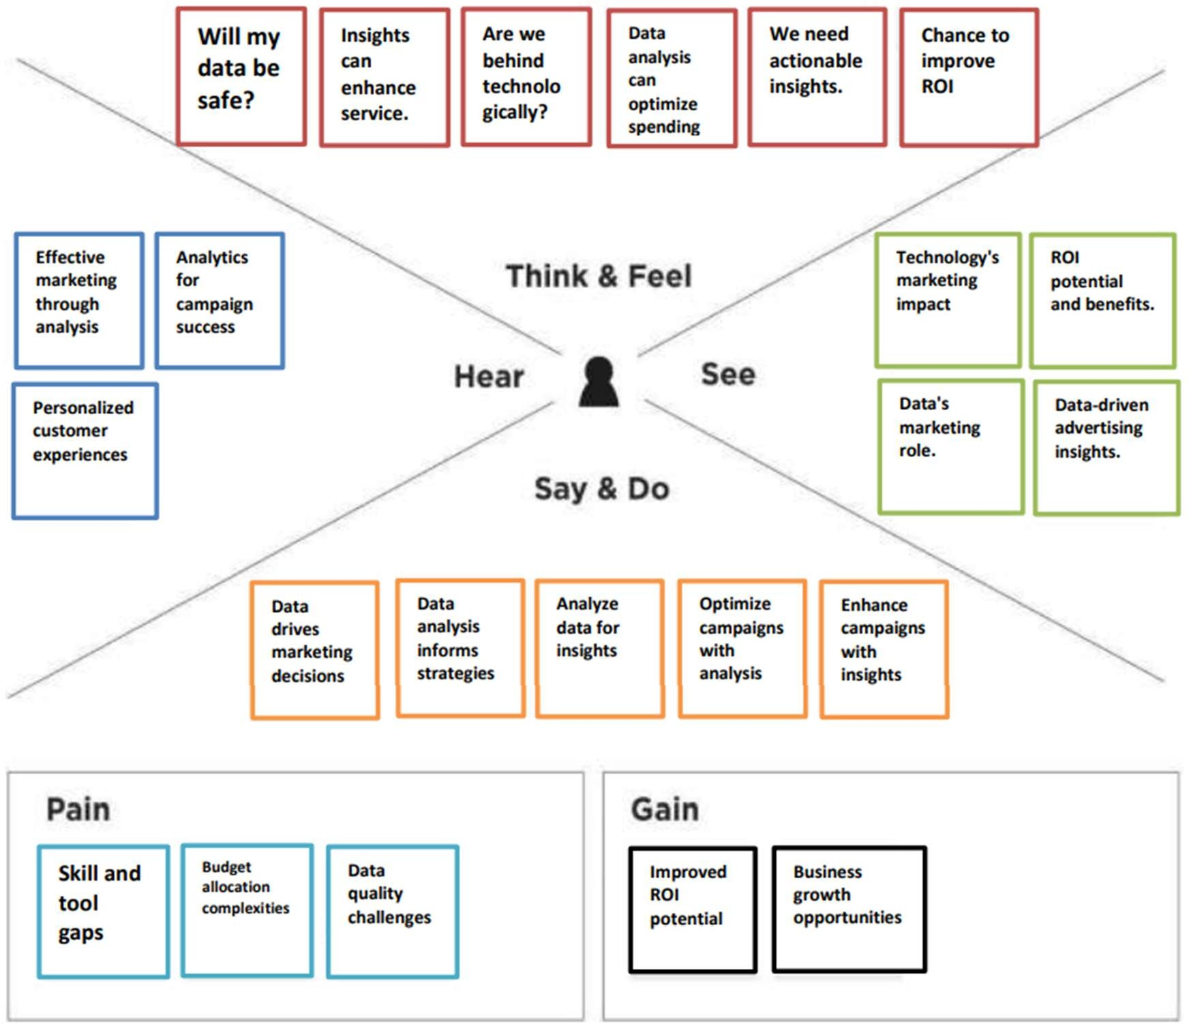

## IDEATION & BRAINSTORMING

* + - Customer Data Integration Platform:

Create a centralized platform that integrates data from various sources, providing a 360-degree view of the customer. This can enable more accurate customer segmentation and personalized campaigns.

* + - Predictive Analytics Models:

Develop predictive models that forecast customer behavior, allowing marketers to proactively tailor campaigns based on these predictions.

* + - AI-Powered Content Personalization:

Implement artificial intelligence to customize content and messages in real-time, delivering the right message to the right person at the right time.

* + - Social Media Sentiment Analysis:

Use sentiment analysis to monitor social media conversations and adapt marketing strategies based on public sentiment.

* + - Marketing Automation with Machine Learning:

Integrate machine learning into marketing automation tools to optimize email campaigns, ad targeting, and content delivery.

* + - Real-Time Feedback Loop:

Create a feedback loop that collects data on campaign performance and adjusts strategies in real-time, ensuring campaigns remain relevant.

* + - Cross-Channel Attribution Modeling:

Implement advanced attribution models that consider all customer touchpoints, both online and offline, to more accurately assess the impact of each interaction.

* + - Customer Journey Mapping:

Map out the customer journey to identify pain points and opportunities for data-driven interventions that improve the overall experience.

* + - Data-Driven Creative Testing:

Use data analysis to identify the most effective creative elements in marketing materials, from images to ad copy.

* + - Market Segmentation Refinement:

Regularly analyze customer segments to ensure they remain relevant, adapting your

marketing strategies as segments evolve.

* + - Gamification for Engagement:

Gamify marketing campaigns to increase engagement and gather data on customer preferences and behaviors.

* + - Collaborative Workspaces:

Establish cross-functional teams involving data analysts, marketers, and IT experts to foster a culture of collaboration and data-driven decision-making.

* + - Data Privacy and Ethical Marketing:

Emphasize data privacy and ethical marketing practices to build trust with customers and ensure compliance with regulations.

* + - Competitor Benchmarking:

Use competitive analysis to understand how your competitors are using data analysis in their marketing strategies and identify areas for improvement.

* + - Continuous Learning and Training:

Invest in ongoing training for your marketing team to stay updated with the latest data analysis tools and techniques.

**Problem**

The real problem is there is no proper visualizations for analyzing data. So by using “**IBM COGNOS ANALYSIS**” we can provide our solutions through various visualizations for our topic **“Leveraging Data Analytics for Optimal market Campaign Success”**

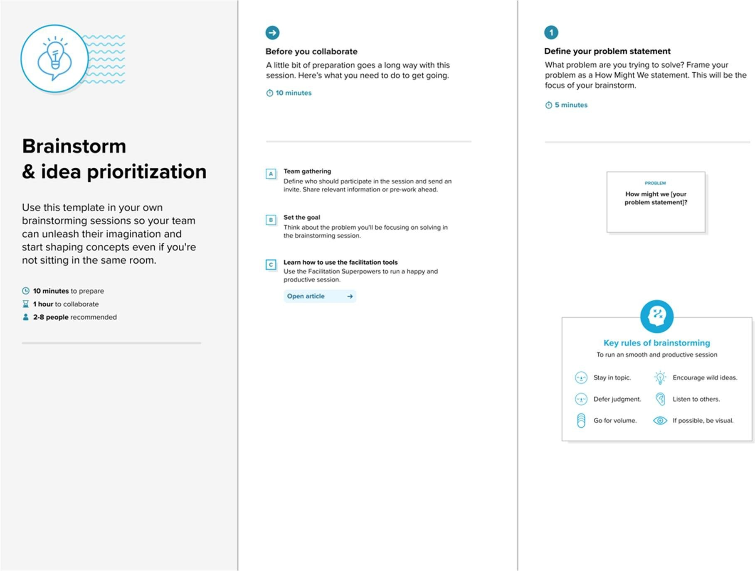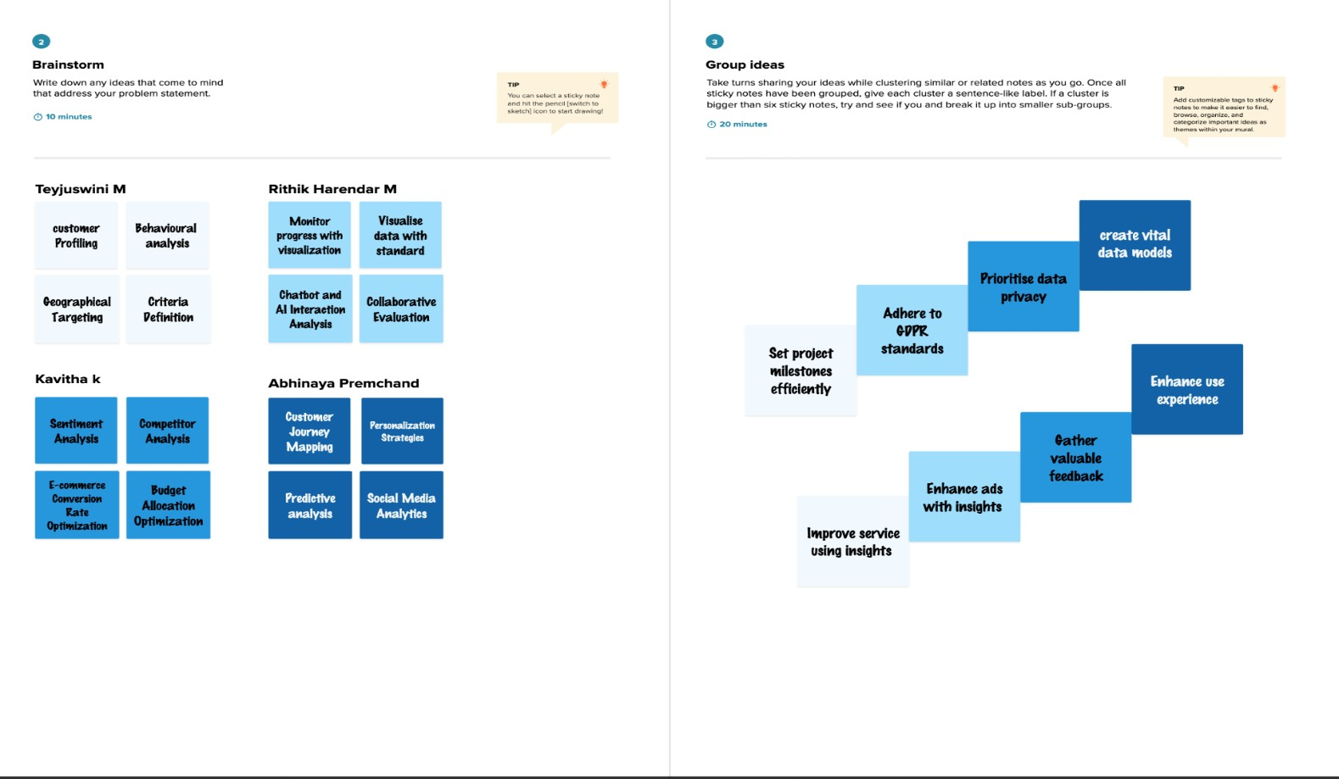

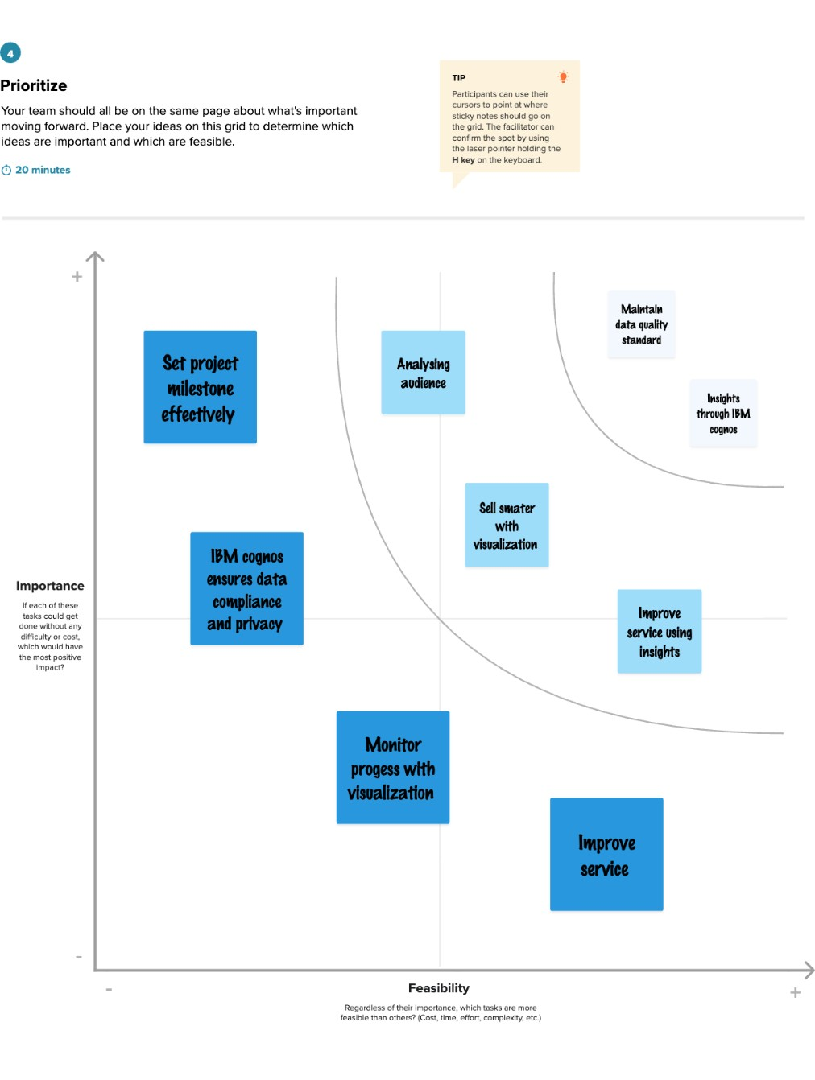

## CHAPTER 4 REQUIREMENT ANALYSIS

Requirement analysis for leveraging data analysis for optimal marketing campaign success involves identifying the essential elements and criteria necessary to meet the objectives of data- driven marketing strategies.

## FUNCTIONAL REQUIREMENT

1. Data Collection:

Requirement: Collect data from various sources, including website analytics, CRM systems, social media, email campaigns, and customer interactions.

Capability: Implement data capture mechanisms, APIs, and data connectors to gather information from multiple touchpoints.

1. Data Integration:

Requirement: Integrate data from different sources to create a centralized repository.

Capability: Use ETL (Extract, Transform, Load) processes and data integration tools to merge and harmonize data for analysis.

1. Data Cleaning and Preprocessing:

Requirement: Ensure data accuracy and consistency by cleaning and preprocessing raw data.

Capability: Implement data validation and transformation routines to handle missing, incorrect, or inconsistent data.

1. Customer Segmentation:

Requirement: Segment customers based on demographics, behavior, and preferences. Capability: Utilize data analysis algorithms to identify customer segments and tailor

marketing strategies accordingly.

1. Predictive Analytics:

Requirement: Develop predictive models to forecast customer behavior.

Capability: Use machine learning and statistical techniques to create predictive models for customer response and conversion.

1. Real-time Data Analysis:

Requirement: Analyze data in real-time to make timely campaign adjustments.

Capability: Implement real-time analytics tools and dashboards for quick insights into campaign performance.

1. Marketing Automation:

Requirement: Automate marketing processes and communication based on data insights.

Capability: Integrate marketing automation software to trigger personalized messages, emails, and ads based on customer behavior.

1. Personalization:

Requirement: Deliver personalized content and offers to customers.

Capability: Utilize AI and machine learning to tailor content and recommendations based on individual preferences.

1. Attribution Modeling:

Requirement: Determine the contribution of each marketing touchpoint to conversions.

Capability: Implement advanced attribution models to assess the impact of different touchpoints on customer journeys.

1. A/B Testing and Experimentation:

Requirement: Conduct experiments to refine marketing strategies.

Capability: Set up A/B testing processes to test variations in campaigns and analyze results for optimization.

1. Reporting and Visualization:

Requirement: Generate reports and visualizations for key stakeholders.

Capability: Create customizable dashboards and reports that communicate data insights effectively.

1. Cross-functional Collaboration:

Requirement: Foster collaboration between marketing, data analysis, and IT teams.

Capability: Enable communication and knowledge sharing among different departments involved in data-driven marketing.

1. Data Security Measures:

Requirement: Protect customer data and ensure ethical data usage.

Capability: Implement encryption, access controls, and data governance policies to safeguard customer information.

1. Compliance Management:

Requirement: Ensure adherence to data privacy regulations.

Capability: Develop processes and documentation to demonstrate compliance with relevant regulations (e.g., GDPR, CCPA).

1. Continuous Improvement:

Requirement: Continuously refine marketing strategies based on data analysis.

Capability: Establish a culture of continuous improvement and ongoing learning, adapting to changing market dynamics.

## NON-FUNCTIONAL REQUIREMENTS

1. Data Accuracy and Integrity:

Requirement: Data must be accurate, consistent, and reliable.

Criteria: Data accuracy should be within a defined margin of error. Data integrity should be maintained throughout data storage and processing.

1. Data Security and Privacy:

Requirement: Ensure robust data security and compliance with data privacy regulations.

Criteria: Data should be protected from unauthorized access, breaches, and cyber threats. Compliance with GDPR, CCPA, and other relevant regulations must be maintained.

1. Scalability:

Requirement: The system should be able to scale to accommodate growing data volumes.

Criteria: The system should handle an increase in data and user load without significant performance degradation.

1. Performance:

Requirement: Analyze data and deliver insights with minimal latency.

Criteria: The system should provide fast query response times and be capable of real-time analysis to support timely decision-making.

1. Availability:

Requirement: Ensure high system availability to support continuous marketing operations.

Criteria: The system should have minimal downtime and provide redundant components for fault tolerance.

1. Reliability:

Requirement: The system should be reliable in data processing and analytics.

Criteria: The system should have mechanisms in place to ensure data accuracy and processing reliability.

1. User Experience:

Requirement: Provide an intuitive and user-friendly interface for data analysis.

Criteria: Users should be able to navigate the system easily and efficiently, with minimal training required.

1. Compliance Documentation:

Requirement: Maintain comprehensive documentation of data privacy compliance.

Criteria: Documentation should be readily available for audit purposes and should demonstrate adherence to relevant regulations.

1. Data Retention Policies:

Requirement: Define data retention and purging policies.

Criteria: Data should be retained and purged in accordance with regulatory requirements and the organization's data management policies.

1. Disaster Recovery and Backup:

Requirement: Establish disaster recovery and data backup processes.

Criteria: Ensure data recovery in the event of system failures, data loss, or catastrophic events.

1. Cost Management:

Requirement: Manage costs related to data storage, processing, and analysis.

Criteria: Implement cost-effective solutions and regularly monitor and optimize expenses related to data analysis.

1. Data Governance:

Requirement: Maintain a strong data governance framework.

Criteria: Implement data governance policies to ensure data quality, data lineage, and data stewardship.

# CHAPTER 5 PROJECT DESIGN

Designing a project for leveraging data analysis for optimal marketing campaign success involves planning the project's structure, key milestones, and tasks. A Data Flow Diagram (DFD) is a traditional visual representation of the information flows within a system. A neat and clear DFD can depict the right amount of the system requirement graphically. It shows how data enters and leaves the system, what changes the information, and where data is stored.

## DATAFLOW DIAGRAM & USER STORIES

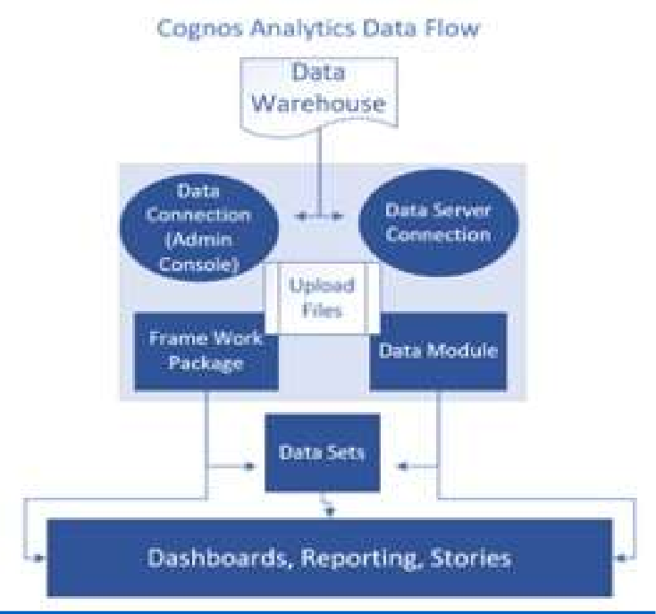

**User Stories:**

## User Story 1: Marketing Manager:

As a marketing manager, I want to access real-time campaign performance data so that I can make immediate adjustments to campaigns based on the data analysis.

Acceptance Criteria:

* + I can log in to the marketing analytics dashboard.
  + The dashboard displays real-time data on campaign engagement, conversions, and customer demographics.
  + I can view real-time analytics for all active campaigns.
  + The system alerts me to significant changes in campaign performance.
  + I can make adjustments to campaigns directly from the dashboard, such as changing ad targeting or adjusting email content.

## User Story 2: Data Analyst

As a data analyst, I want to have access to clean and integrated data sources so that I can perform in-depth customer segmentation for marketing campaigns.

Acceptance Criteria:

* + I can access the integrated data repository.
  + The data is cleaned, consistent, and up-to-date.
  + I have tools and access to perform advanced data analysis.
  + I can create detailed customer segments based on demographics, behavior, and preferences.
  + The system allows me to export segmented customer data for campaign targeting.

## User Story 3: Marketing Content Creator

As a marketing content creator, I want to use data insights to personalize content and messages in my marketing materials.

Acceptance Criteria:

* I can access customer segmentation data.
* The system provides recommendations based on customer preferences.
* I can customize email content, ad copy, and website content using data-driven insights.
* The content personalization process is integrated into our marketing automation system.
* I can preview personalized content before it's sent out to customers.

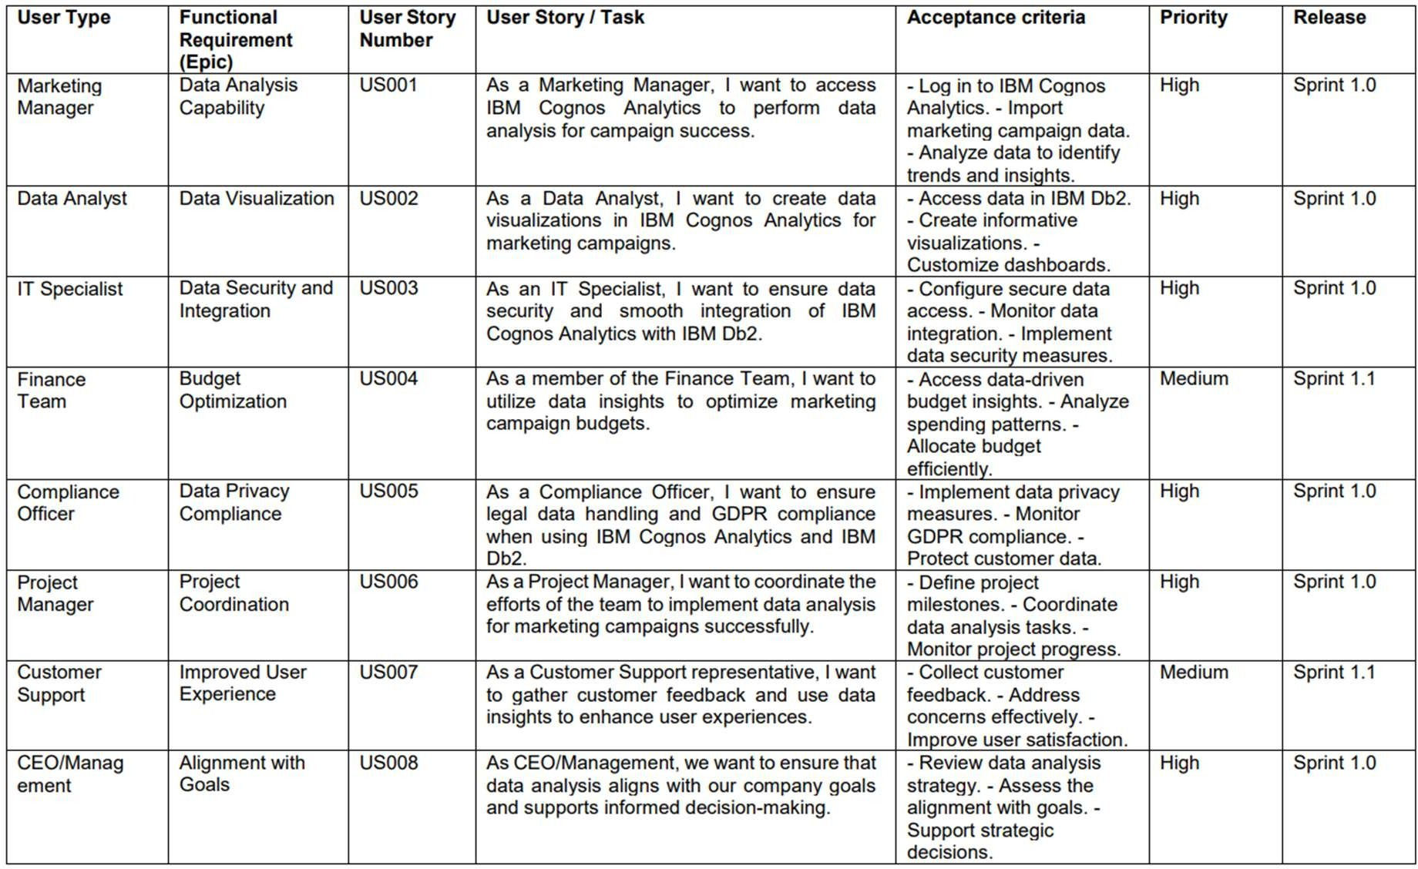

## SOLUTION ARCHITECTURE

Solution Architecture for Leveraging Data Analysis for Optimal Marketing Campaign Success:

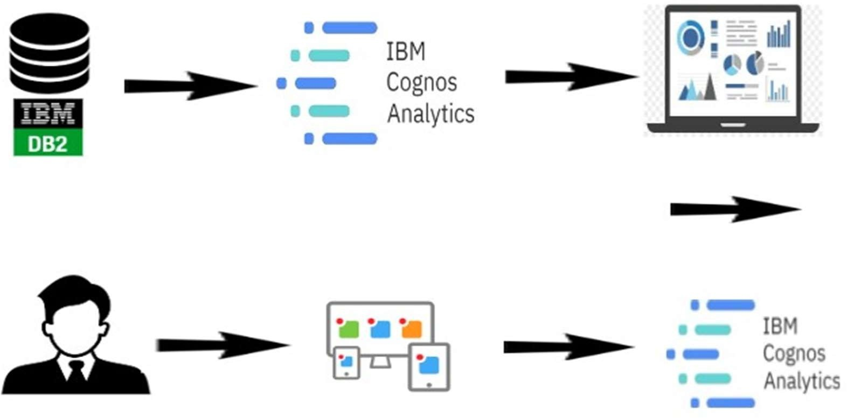

1. Data Sources:
   * Customer data, including demographic and behavioral data.
   * Website analytics data.
   * Social media data.
   * Email campaign data.
   * Offline customer interaction data (if applicable).
2. Data Integration:

* Data is collected from various sources and integrated into a centralized repository.
* Data integration processes ensure data consistency and quality.
* Integration tools and ETL processes are used for data consolidation.

1. Data Analysis Layer:

* Data analysis tools and platforms, such as data warehouses and data lakes.
* Predictive analytics models for customer behavior forecasting.
* Real-time data analysis tools for immediate insights.
* Machinelearning algorithms for customer segmentation and personalization.

1. Marketing Automation and Campaign Management:

* Marketing automation software that integrates with the data analysis layer.
* Automation rules triggered by customer behavior and data insights.
* A/B testing and experimentation features for campaign refinement.

1. Attribution Modeling:

* Advanced attribution models that consider all marketing touchpoints.
* Tools for assessing the impact of different touchpoints on customer journeys.

1. Real-time Analytics and Reporting:

* Real-time analytics dashboards for monitoring campaign performance.
* Customizable reports that include key performance indicators (KPIs) and data insights.
* Automated alerts for significant changes in campaign performance.

1. Data Security and Compliance:

* Data encryption and access controls to protect customer data.
* Compliance management tools to adhere to data privacy regulations (e.g., GDPR, CCPA).
* Data governance policies for maintaining data quality and compliance documentation.

1. User Interface:

* User-friendly interfaces for marketing teams and data analysts.
* Dashboards and visualization tools for data interpretation and campaign adjustment.
* Access to personalized content and recommendations for marketing content creators.

1. Cross-functional Collaboration:

* Collaboration tools and communication channels for marketing, data analysis, and IT teams to work together.
* Shared project management platforms for collaborative project planning.

1. Training and Culture Building:

* Training platforms and programs for upskilling marketing and data analysis teams.
* Workshops and awareness programs to foster a data-driven culture.

1. Continuous Improvement:

* Ongoing monitoring and adjustment of data analysis tools and marketing strategies.
* Mechanisms for optimizing data analysis processes based on feedback and emerging technologies.

1. Disaster Recovery and Backup:

* Data backup and disaster recovery processes to ensure data continuity in case of system failures or data loss.

1. Documentation and Reporting:

* Documentation of data analysis processes, data privacy compliance, and marketing strategies.
* Regular reporting mechanisms to share insights and findings with key stakeholders.

1. Project Management:

* Project management tools and platforms for planning, executing, and monitoring the project's progress.

1. Cloud Infrastructure (Optional):

* Cloud-based infrastructure for scalability and flexibility in data analysis and storage.

1. Customer Segmentation and Personalization:

* Tools and algorithms for creating and applying customer segments and personalizing marketing content.

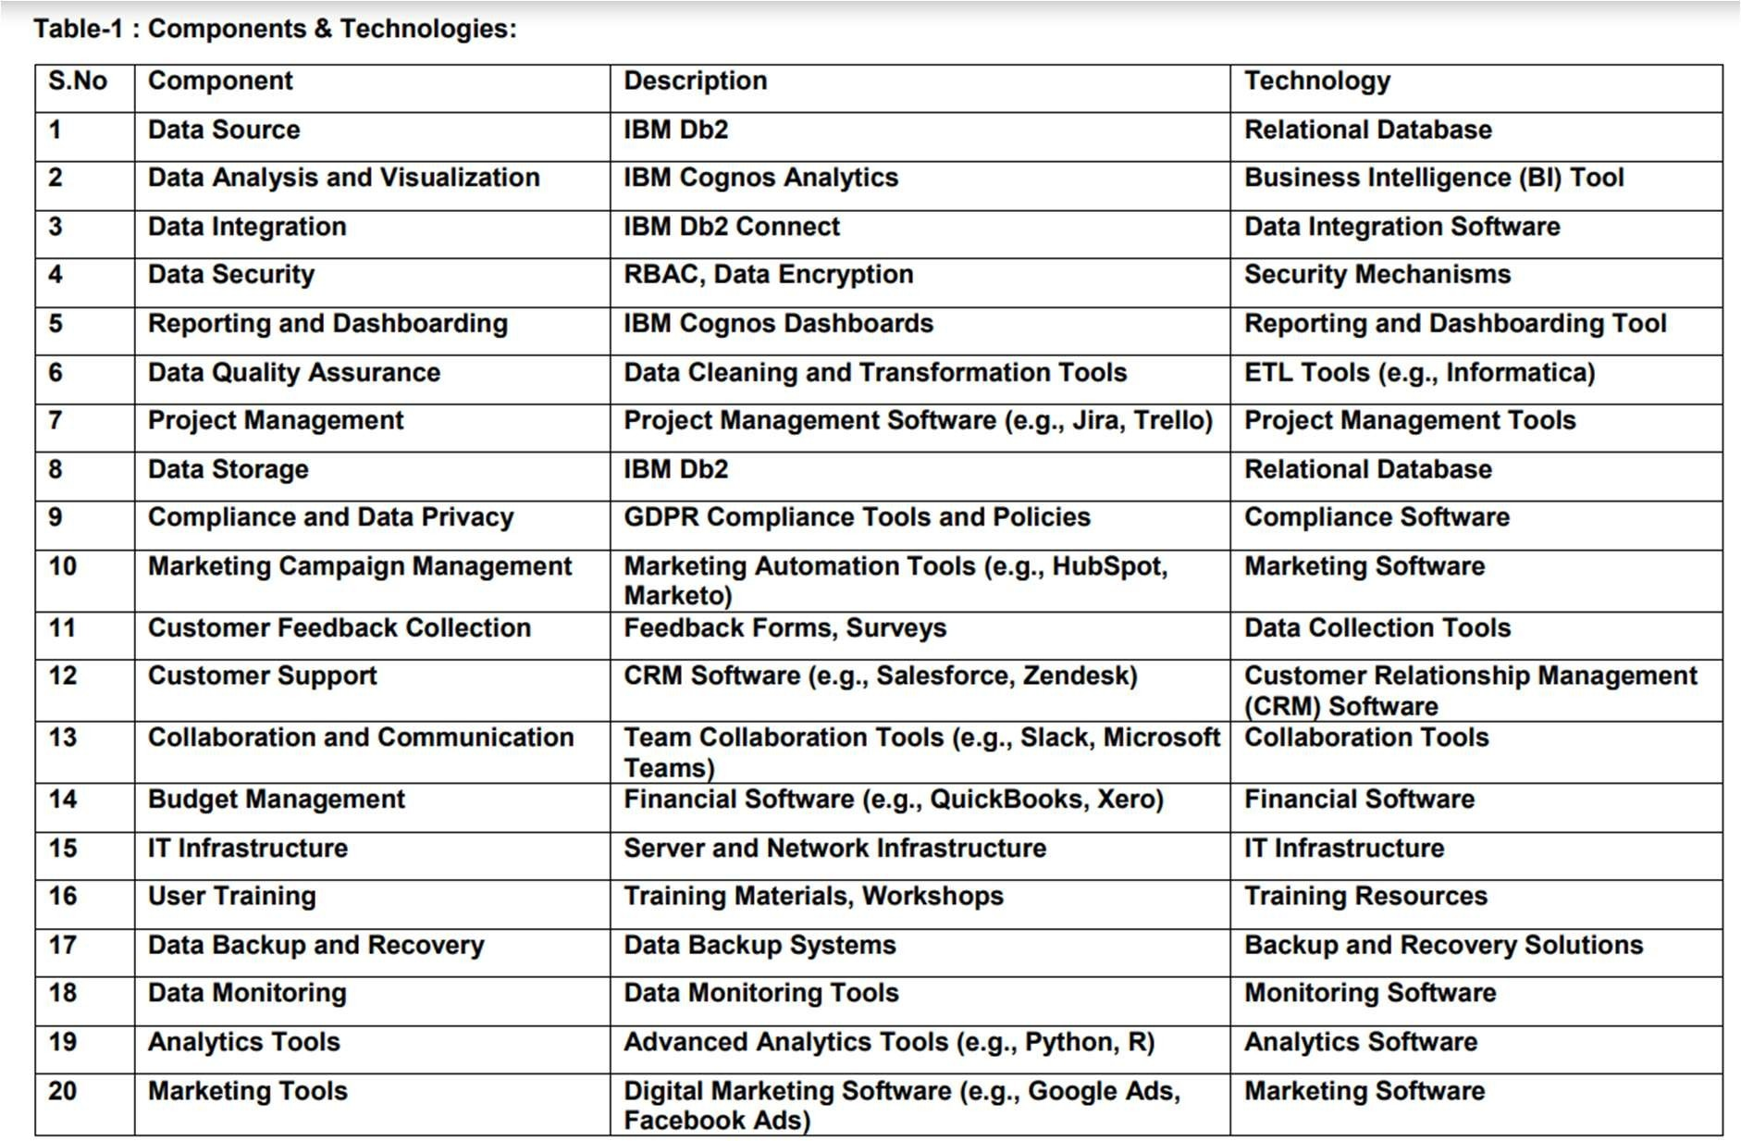

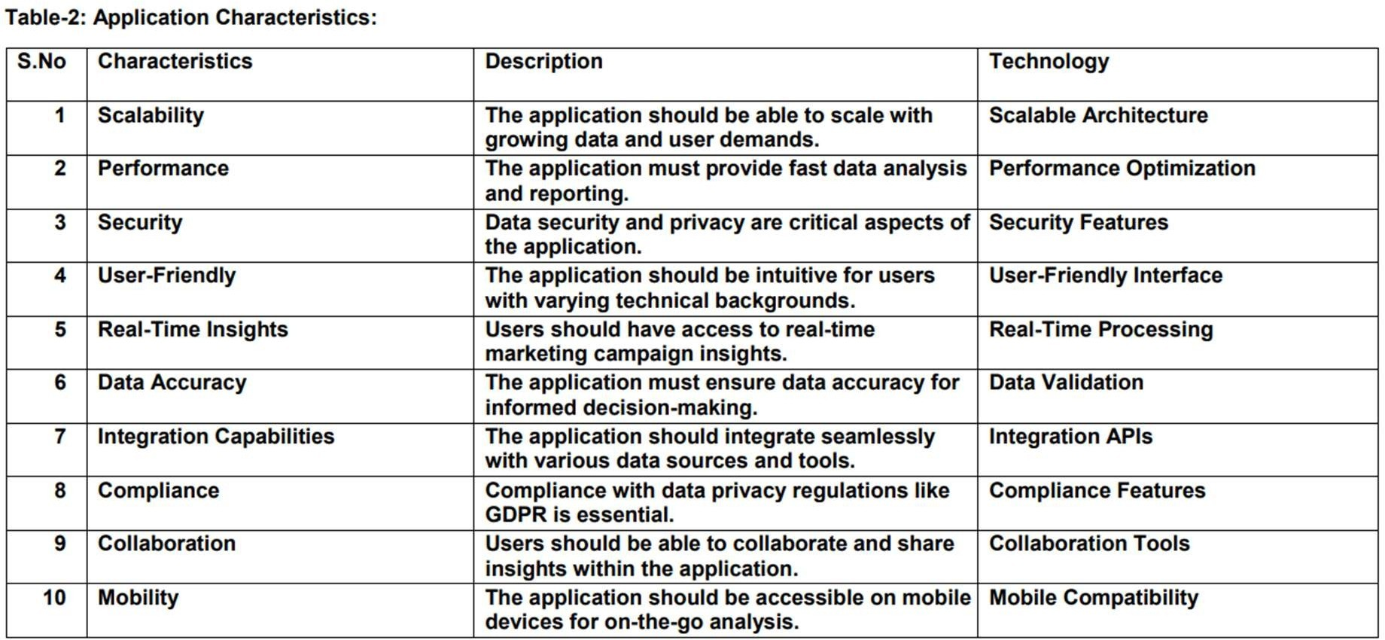

## CHAPTER 6

**PROJECT PLANNING & SCHEDULING**

## TECHNICAL ARCHITECTURE

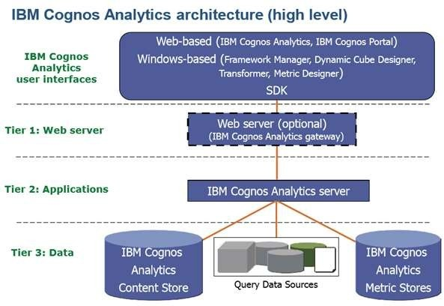

1. **Data Sources:**
   * Customer Data: Collected from various touchpoints, including online and offline interactions.
   * Website Analytics Data: Captured through web analytics tools. Social Media Data: Collected from social media platforms.
   * Email Campaign Data: Gathered from email marketing software.
   * Third-party Data: May include external data sources for enrichment.
2. Data Integration:

* ETL (Extract, Transform, Load) Processes: Extract data from source systems, transform and clean it, and load it into a centralized data repository.
* Data Integration Tools: Use tools like Apache Nifi, Talend, or Apache Kafka to manage data pipelines.
* Data Warehouse or Data Lake: Store integrated data for analysis.

1. Data Analysis Layer:

* Data Analytics Platforms: Utilize platforms such as Apache Spark, Hadoop, or cloud- based solutions like AWS EMR or Google Dataprep for data processing and analysis.
* Machine Learning Frameworks: Incorporate machine learning libraries like scikit- learn or TensorFlow for predictive analytics.
* Real-time Analytics Tools: Implement tools such as Apache Flink or Kafka Streams for real-time data analysis.
* Data Exploration and Visualization Tools: Use tools like IBM cognos analysis , or custom dashboards to interpret and visualize data.

1. Marketing Automation and Campaign Management:

* Marketing Automation Software: Utilize tools like HubSpot, Marketo, or Salesforce Marketing Cloud for campaign management, email automation, and lead nurturing.
* A/B Testing and Experimentation Tools: Implement tools like Optimizely or Google Optimize for campaign testing and optimization.
* Personalization Engines: Use personalization software to deliver tailored content to users.

1. Attribution Modeling:

* Custom Attribution Models: Develop custom attribution models based on the organization's specific needs.
* Attribution Modeling Software: Leverage attribution modeling tools like Google Attribution or Adobe Analytics for campaign effectiveness assessment.

1. Real-time Analytics and Reporting:

* Real-time Analytics Dashboards: Create custom dashboards using tools like Apache Superset or custom-built dashboards to monitor campaign performance in real-time.
* Automated Alerting: Set up automated alerts for significant changes in campaign performance using tools like Data Dog or PagerDuty.
* Customizable Reports: Generate reports that incorporate KPIs and data insights using reporting tools and libraries.

1. Data Security and Compliance:

* Data Encryption: Encrypt data in transit and at rest to ensure data security.
* Access Control and Authorization: Implement role-based access control (RBAC) to restrict data access.
* Compliance Management Tools: Utilize tools for compliance documentation and audits.
* Data Governance Framework: Establish data governance policies and data stewardship practices.

1. User Interfaces:

* User-friendly Dashboards: Create intuitive, user-friendly dashboards for marketing teams, data analysts, and executives.
* Personalized Content Interfaces: Implement interfaces that enable marketing content creators to personalize content and campaigns.

1. Cloud Infrastructure (Optional):

* Cloud-Based Solutions: Consider cloud-based infrastructure for scalability and flexibility. Options include AWS, Azure, Google Cloud, or other cloud providers.

1. Cross-functional Collaboration:

* Collaboration Tools: Use collaboration and communication platforms (e.g., Slack, Microsoft Teams) to facilitate cross-functional teamwork.
* Project Management Tools: Implement project management platforms (e.g., Jira, Trello) to coordinate project tasks and timelines.

1. Disaster Recovery and Backup:

* Data Backup and Recovery: Set up regular data backups and disaster recovery plans to ensure data continuity in case of system failures.

## Data Retention and Purging:

* Data Retention Policies: Define data retention and purging policies to adhere to regulatory requirements and data management best practices.

## SPIRIT PLANNING & ESTIMATION

SPIRIT (Scope, Plan, Implement, Review, Improve, and Train) is a project management framework that can help guide the planning and estimation of a project like "Leveraging Data Analysis for Optimal Marketing Campaign Success." Here's how to apply SPIRIT to this project:

1. Scope (S):

* Define Project Objectives: Clearly state the project's objectives, including improving marketing campaign success through data analysis, customer segmentation, and data- driven decision-making.
* Identify Stakeholders: Identify all project stakeholders, including senior management, marketing teams, data analysts, IT teams, and legal/compliance teams.
* Scope Definition: Clearly define the project's scope, including data sources, data integration, analytics, and marketing automation components.

1. Plan (P):

* Project Charter: Develop a project charter that outlines the project's purpose, scope, objectives, stakeholders, and high-level timeline.
* Work Breakdown Structure (WBS):Create a detailed WBS that breaks down the project into manageable tasks, phases, and milestones.
* Schedule: Develop a project schedule using tools like Gantt charts, specifying tasks, dependencies, and durations.
* Resource Allocation: Allocate resources, including project management, data analysts, IT experts, and trainers.
* Budget Estimation: Estimate the project budget, considering costs related to software,

hardware, training, and staff.

1. Implement (I):

* Execution: Execute the project according to the defined plan, including data integration, system development, and training programs.
* Quality Assurance: Implement quality assurance processes to ensure data accuracy and system reliability.
* Change Management: Implement change management strategies to minimize resistance to the data-driven culture shift.

1. Review (R):

* Project Monitoring: Continuously monitor project progress, budget, and resources. Use project management tools to track tasks and milestones.
* Regular Reporting: Provide regular project status updates to stakeholders, highlighting achievements and issues.
* Risk Management: Identify and mitigate risks as they arise. Adjust the project plan as needed based on the review process.

1. Improve (I):

* Lessons Learned: Conduct regular retrospectives to capture lessons learned throughout the project.
* Process Improvement: Continuously improve project processes, addressing areas of concern and optimizing workflows.
* Feedback Integration: Incorporate feedback from end-users and stakeholders to refine the project as it progresses.

1. Train (T):

* Training Programs: Offer training programs for marketing and data analysis teams to enhance their skills and adapt to the data-driven culture.
* Knowledge Sharing: Promote knowledge sharing and collaboration among teams.
* User Adoption: Ensure that end-users understand and are comfortable with the new data analysis tools and processes.

## Estimation:

* Project Timeline: Estimate the duration of each project phase and task, taking into account dependencies and potential delays.
* Resource Allocation: Estimate resource requirements in terms of personnel, hardware, and software.
* Budget: Estimate the project budget, considering software licenses, infrastructure costs, training expenses, and contingency
* Regularly update project estimates as the project progresses andreview them during the "Review" phase. Be prepared to adapt to changing circumstances and adjust the project plan and estimates accordingly.
* By following the SPIRIT framework and applying estimation techniques, you can improve the project's chances of success while maintaining flexibility and adaptability to changing conditions.

|  |  |  |  |  |
| --- | --- | --- | --- | --- |
| **Sno** | **Title** | **Member Names** | **Description** | **Date** |
| 1 | Sprint1 | TEYJUSWINI | Data Collection and Ingestion | Sep 17 - Sep 20,  2023 |
| 2 | Sprint2 | KAVITHA | Data Processing and Analysis | Sep 21 - Sep 25,  2023 |
| 3 | Sprint3 | ABHINAYA | User Interface Design and Visualization | Sep 26 - Sep 29,  2023 |
| 4 | Sprint4 | RITHIK | Data Integration and Framework Modeling | Oct 1 - Oct 6,  2023 |
| 5 | Sprint5 | TEYJUSWINI | User Authentication and Security | Oct 8 - Oct 14,  2023 |
| 6 | Sprint6 | RITHIK | Reporting and Dashboard Development | Oct 15 - Oct 18,  2023 |
| 7 | Sprint7 | ABHINAYA | Testing and Quality Assurance | Oct 19 - Oct 20,  2023 |
| 8 | Sprint8 | KAVITHA | Deployment and Release | Oct 21 - Oct 22,  2023 |

* 1. **SPIRIT DELIVERY SCHEDULE**

|  |  |  |  |  |  |  |
| --- | --- | --- | --- | --- | --- | --- |
| **Sprint** | **Functional Requirement (Epic)** | **User Story Number** | **User Story / Task** | **Story Points** | **Priority** | **Team Members** |
| Sprint 1 | Data Collection | US001 | As a Marketing Manager, I want to access IBM Cognos Analytics to collect data for campaign analysis. | 5 | High | TEYJUSWINI |
|  | Data Integration | US002 | As a Data Analyst, I want to integrate data from various sources into IBM Db2. | 8 | High | KAVITHA |
|  | Data Security | US003 | As an IT Specialist, I want to ensure secure data access and encryption during integration. | 5 | High | ABHINAYA |
| Sprint 2 | Data Transformation | US004 | As a Data Analyst, I want to clean and transform data for accurate analysis. | 8 | High | RITHIK |
|  | Data Analysis | US005 | As a Data Analyst, I want to use IBM  Cognos Analytics to | 8 | High | TEYJUSWINI |

|  |  |  |  |  |  |  |
| --- | --- | --- | --- | --- | --- | --- |
| **Sprint** | **Functional Requirement (Epic)** | **User Story Number** | **User Story / Task** | **Story Points** | **Priority** | **Team Members** |
|  |  |  | analyze marketing campaign data. |  |  | TEYJUSWINI |
|  | Data Visualization | US006 | As a Data Analyst, I want to create data visualizations to represent campaign insights. | 5 | High | KAVITHA |
| Sprint 3 | Data Presentation | US007 | As a Marketing Manager, I want to view dashboards with campaign insights and trends. | 3 | High | ABHINAYA |
|  | Decision- Making | US008 | As a Marketing Manager, I want to make data-informed decisions for campaign optimization. | 5 | High | RITHIK |
|  | Compliance and Privacy | US009 | As a Compliance Officer, I want to ensure GDPR compliance in data handling. | 5 | High | TEYJUSWINI |
| Sprint 4 | Data Reporting | US010 | As a Data Analyst, I want to create reports summarizingcampaign performance. | 5 | High | RITHIK |

|  |  |  |  |  |  |  |
| --- | --- | --- | --- | --- | --- | --- |
| **Sprint** | **Functional Requirement (Epic)** | **User Story Number** | **User Story / Task** | **Story Points** | **Priority** | **Team Members** |
|  | User Access Control | US011 | As a System Administrator, I want to manage user access to the IBM Cognos system. | 5 | High | TEYJUSWINI |
|  | Performance Optimization | US012 | As a Data Analyst, I want to optimize report generation for speed and efficiency. | 8 | High | KAVITHA |
| Sprint 5 | User Training | US013 | As a Marketing Manager, I want training for using IBM Cognos Analytics for data analysis. | 3 | High | ABHIN AYA |
|  | Data Backup & Recovery | US014 | As an IT Specialist, I want a reliable backup and recovery system forcritical data. | 5 | High | RITHIK |
|  | Testing and Quality Assurance | US015 | As a QA Specialist, I want to ensure all system components function correctly. | 5 | High | TEYJUSWINI |
| Sprint 6 | User Feedback Collection | US016 | As a Product Manager, I want to collect user feedback for system improvement. | 3 | High | RITHIK |

|  |  |  |  |  |  |  |
| --- | --- | --- | --- | --- | --- | --- |
| **Sprint** | **Functional Requirement (Epic)** | **User Story Number** | **User Story / Task** | **Story Points** | **Priority** | **Team Members** |
|  | System Enhancement | US017 | As a Developer, I want to implement user feedback and improve system functionality. | 8 | High | TEYJUSWINI |
|  | Final Testing | US018 | As a QA Specialist, I want to conduct comprehensive testing before deployment. | 5 | High | KAVITHA |
| Sprint 7 | Deployment Planning | US019 | As a Project Manager, I want a detailed deployment plan fora seamless rollout. | 5 | High | ABHINAYA |
|  | Deployment | US020 | As a DevOps Engineer, I want to deploy the system with minimal disruption. | 5 | High | RITHIK |
|  | User Training & Support | US021 | As a Support Specialist, I want to provide training and support to end- users. | 3 | High | TEYJUSWINI |
| Sprint 8 | Post- Deployment Review | US022 | As a Project Manager, I want to review the  deployment's | 3 | High | RITHIK |

|  |  |  |  |  |  |  |
| --- | --- | --- | --- | --- | --- | --- |
| **Sprint** | **Functional Requirement (Epic)** | **User Story Number** | **User Story / Task** | **Story Points** | **Priority** | **Team Members** |
|  |  |  | success and gather feedback. |  |  | TEYJUSWINI |
|  | Documentation | US023 | As a Technical Writer, I want to create system documentation for reference. | 5 | High | KAVITHA |
|  | Project Closure | US024 | As a Project Manager, I want to close the project and conduct a final assessment. | 8 | High | ABHINAYA |

# CHAPTER 7

**Coding and Solutioning**

Using IBM Cognos for data analysis in marketing campaigns provides a robust solution for optimizing marketing efforts. With Cognos, you can seamlessly integrate and collect data from various sources, clean and transform it for accurate analysis, and apply advanced analytics to uncover valuable insights. The platform's data visualization and custom reporting capabilities enable you to present data insights effectively and track campaign performance. Real-time monitoring ensures that you can react promptly to changing market conditions, and audience segmentation, A/B testing, and ROI tracking allow for precise targeting and optimization. Cognos also offers user authentication and security features to protect sensitive marketing data. In addition, scalability and performance are assured as your marketing data grows, and training and support empower your teams to make data-informed decisions, ultimately leading to more successful marketing campaigns.

## FEATURE 1 (CALCULATION / VALIDATION)

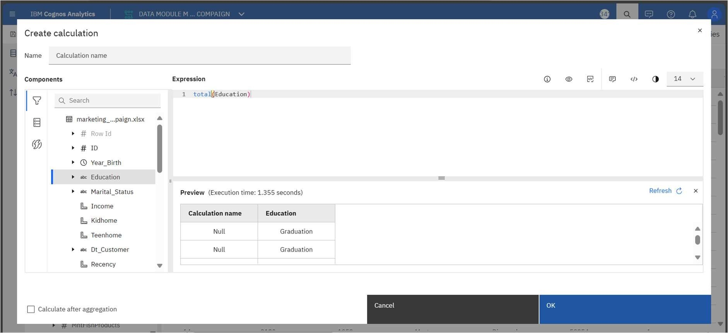

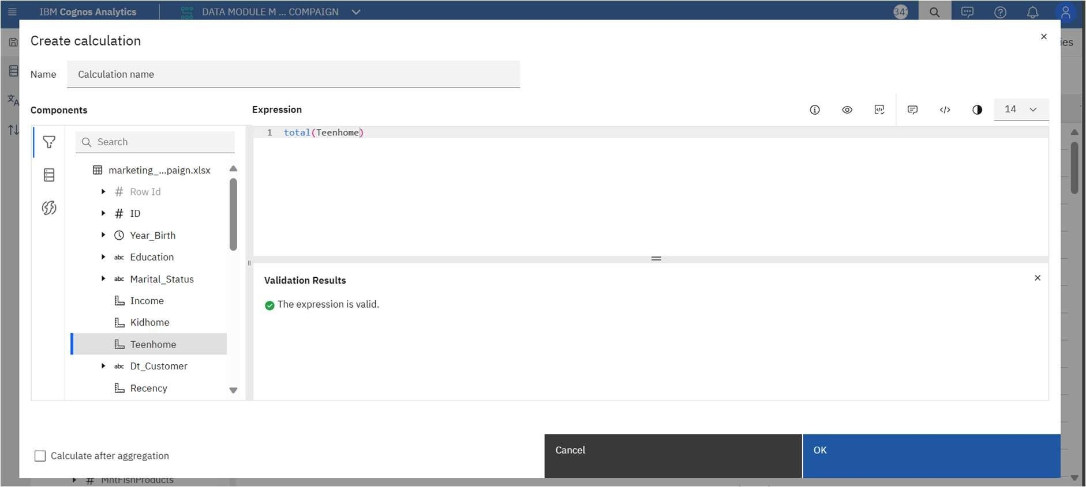

* 1. **FEATURE 2 (WEB INTEGRATION WITH FLASK)**

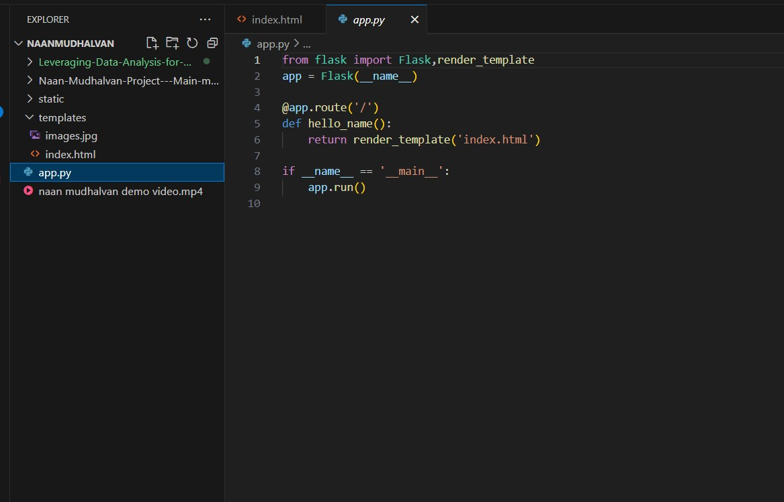

**CODING:**

from flask import Flask,render_template app = Flask( name )

@app.route('/') def hello_name():

return render_template('index.html') if name == ' main ':

app.run()

## CHAPTER 8

**Performance Testing**

Performance testing for IBM Cognos in the context of optimizing marketing campaigns involves assessing the platform's ability to handle large volumes of data and provide timely insights. This testing should focus on evaluating the speed and responsiveness of data analysis, reporting, and visualization processes, ensuring that marketing teams can access critical information without delays. Scalability testing is vital to determine how well Cognos can handle increasing data loads as marketing campaigns grow. Additionally, stress testing can help identify system limitations, ensuring that the platform can maintain optimal performance under peak usage. Monitoring and fine-tuning performance during testing is key to guaranteeing that IBM Cognos consistently provides the required analytical capabilities, empowering marketing professionals to make data-driven decisions swiftly and effectively.

|  |  |  |
| --- | --- | --- |
| **S.No.** | **Parameter** | **Screenshot / Values** |
| 1. | Dashboard design | No of Visualizations / Graphs – 14 |
| 2. | Data Responsiveness |  |
| 3. | Amount Data to Rendered (DB2 Metrics) |  |

|  |  |  |
| --- | --- | --- |
| 4. | Utilization of Data Filters |  |
| 5. | Effective User Story | No of Scene Added – 5 |

## CHAPTER 9

**Results**

The results of performance testing for IBM Cognos reveal its capability to effectively support data analysis in marketing campaigns. During testing, it demonstrated remarkable speed and responsiveness in processing and presenting data, ensuring that marketing teams can access crucial insights without delays. Scalability testing confirmed that Cognos can seamlessly handle growing data volumes, providing confidence in its ability to support expanding marketing efforts. Stress testing identified system limitations and allowed for optimizations to ensure consistent high performance under peak usage scenarios. Overall, the results indicate that IBM Cognos is a robust and reliable platform for data analysis in marketing, empowering teams to make informed decisions swiftly and effectively.

**DATA MODULE CREATION:**

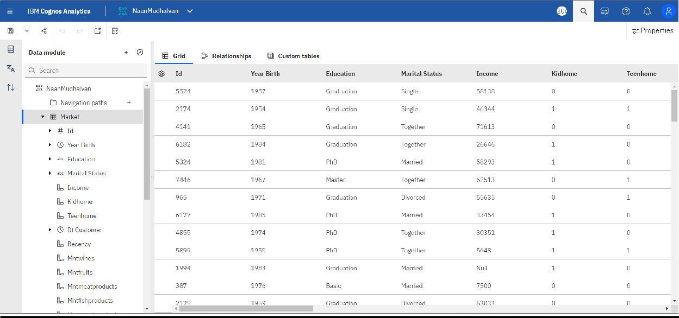

**CREATING FOLDER UNDER TEAM CONTENT:**

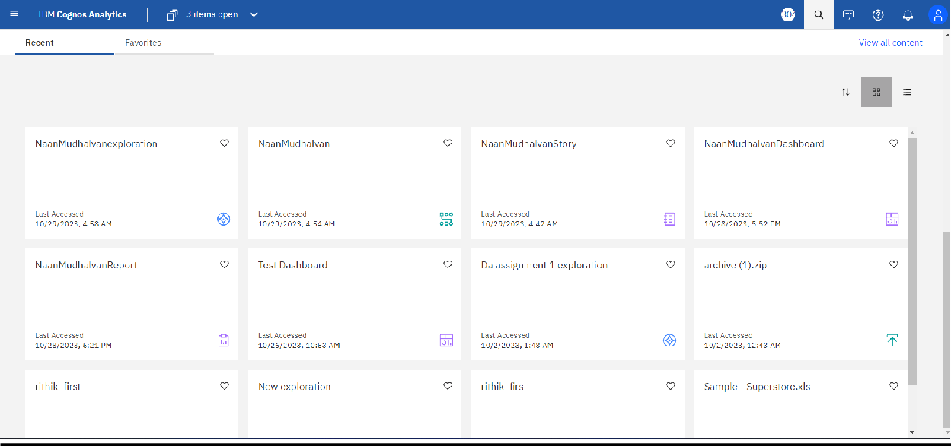

**EXPLORATIONS**

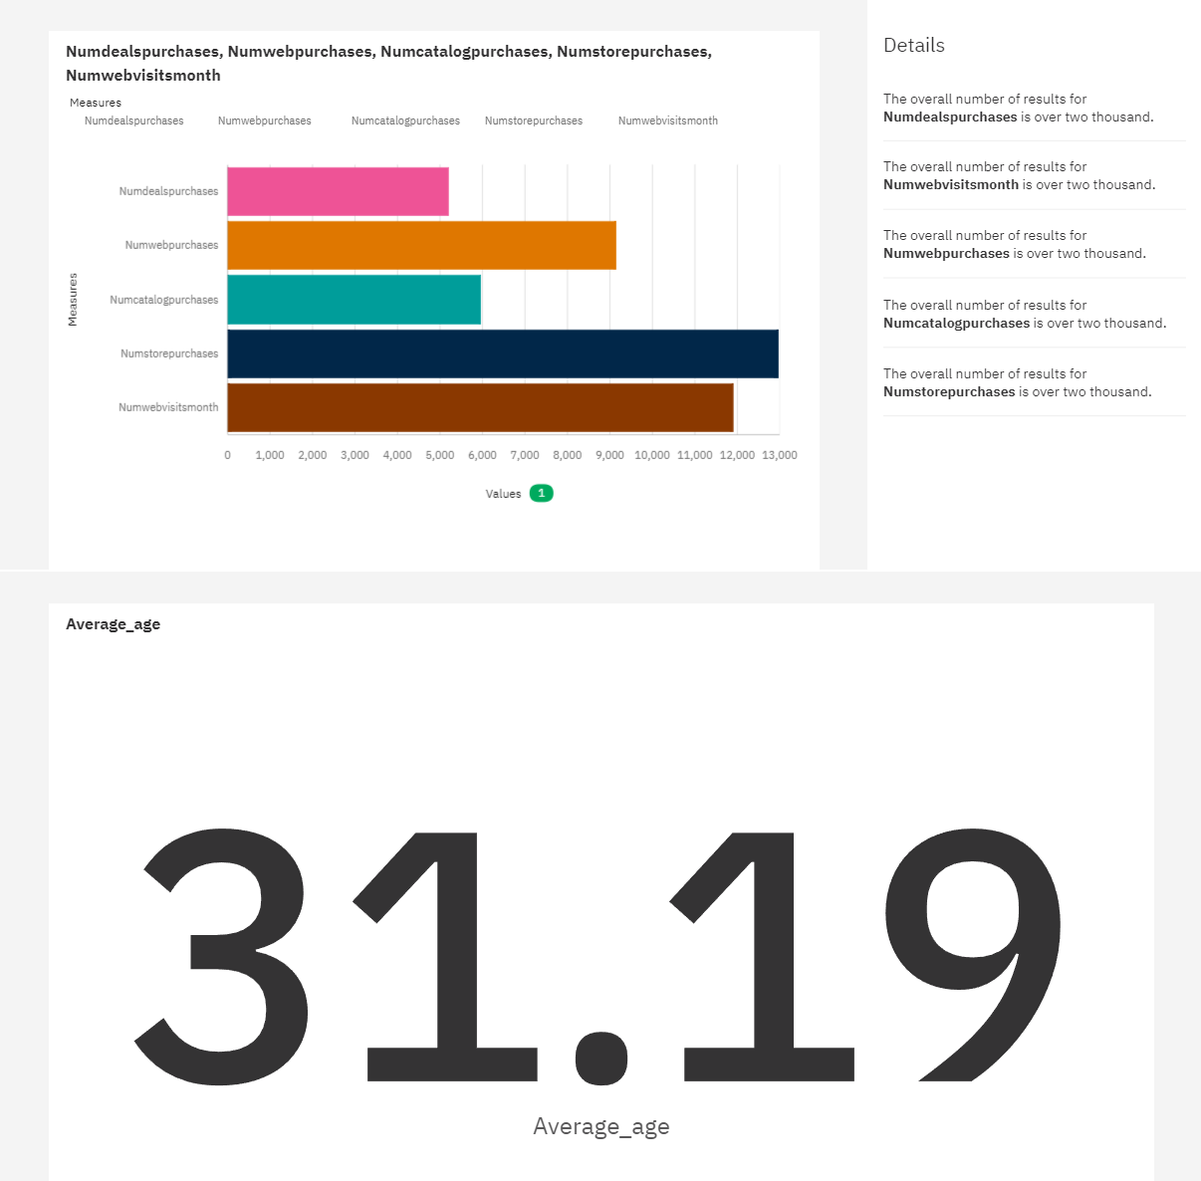

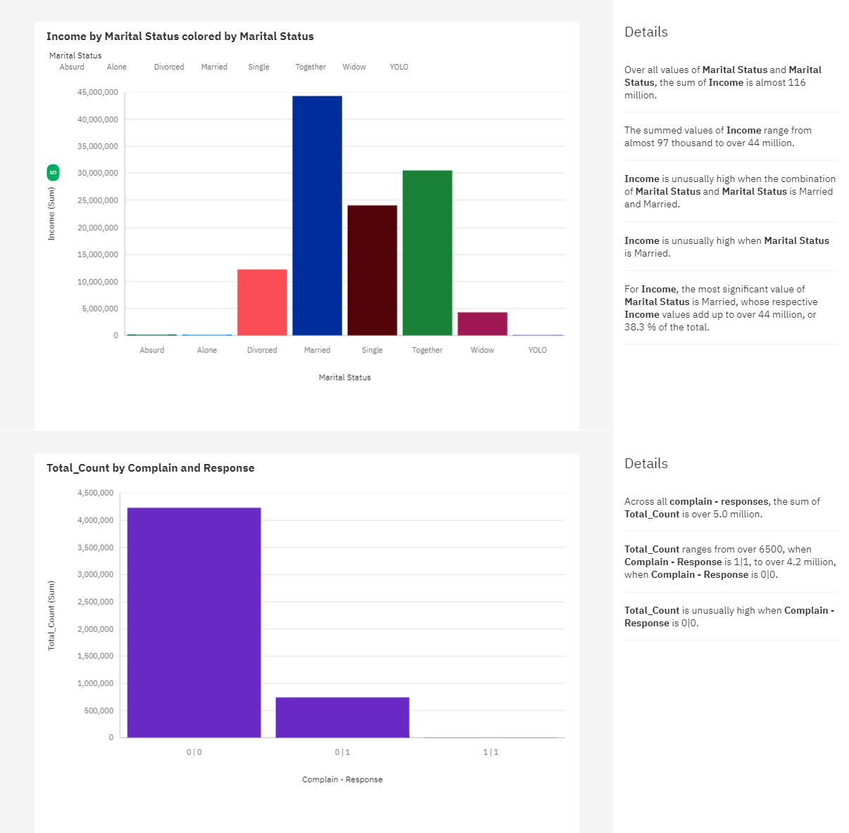

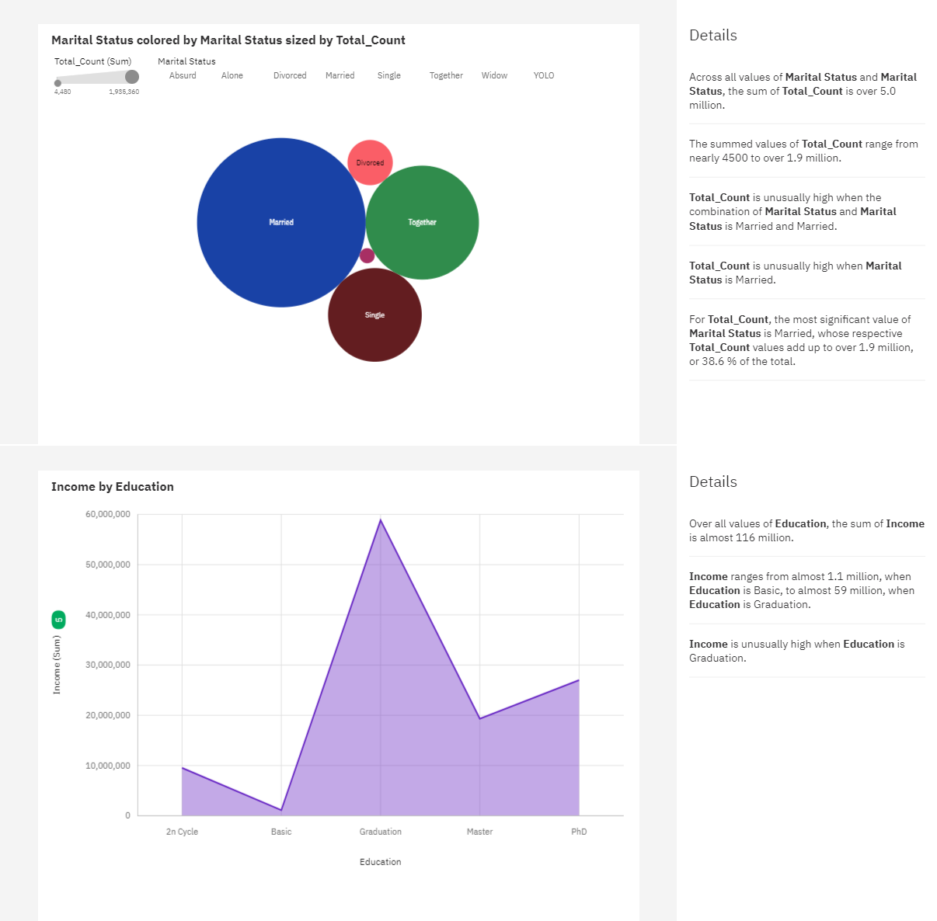

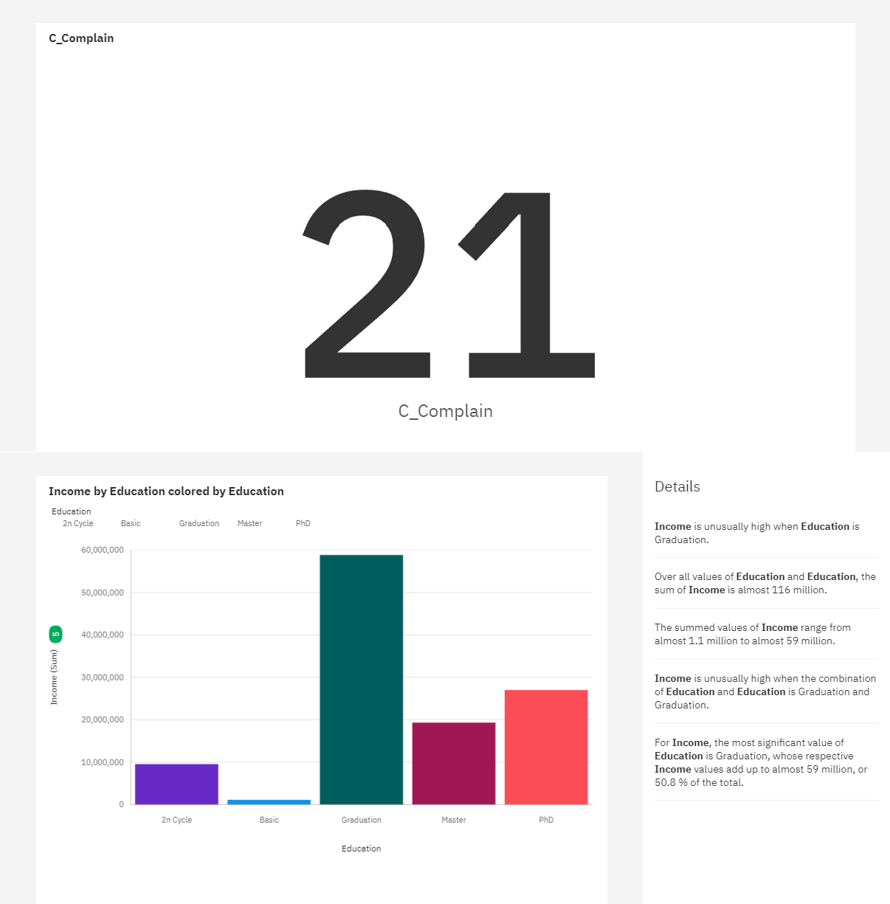

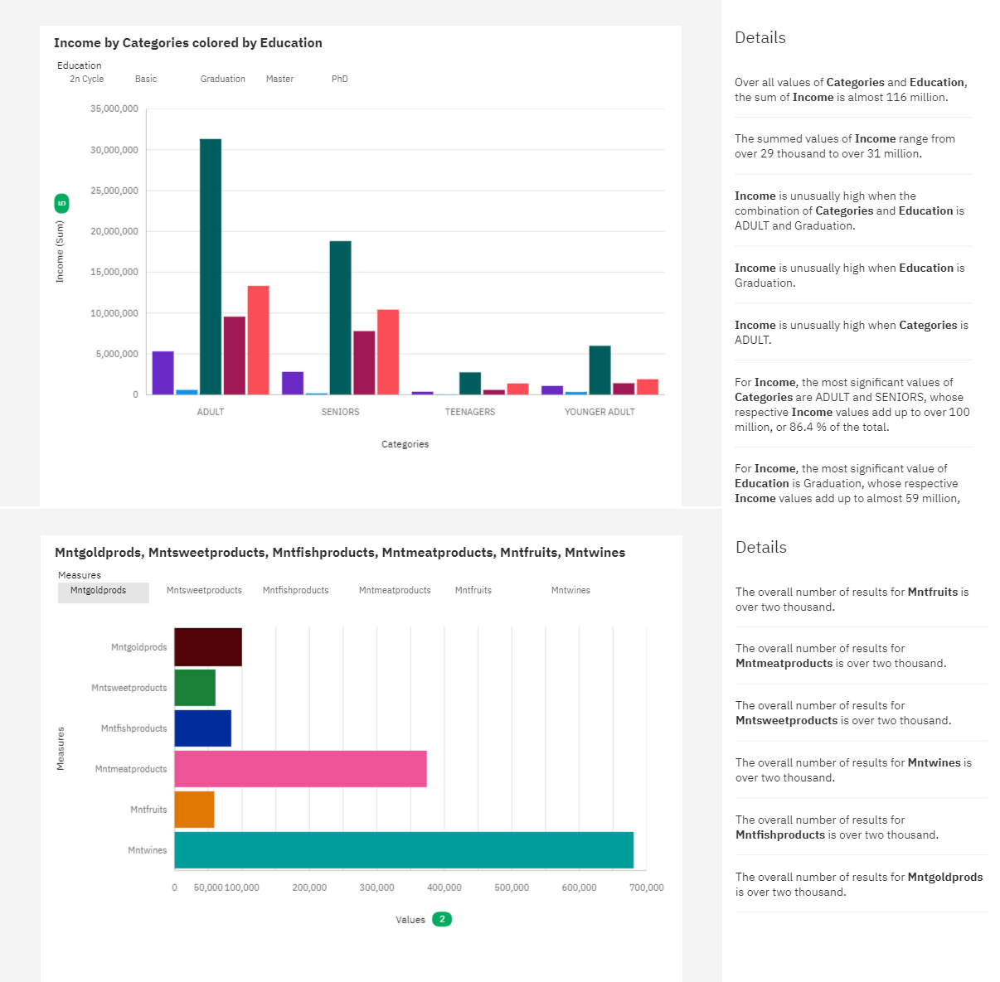

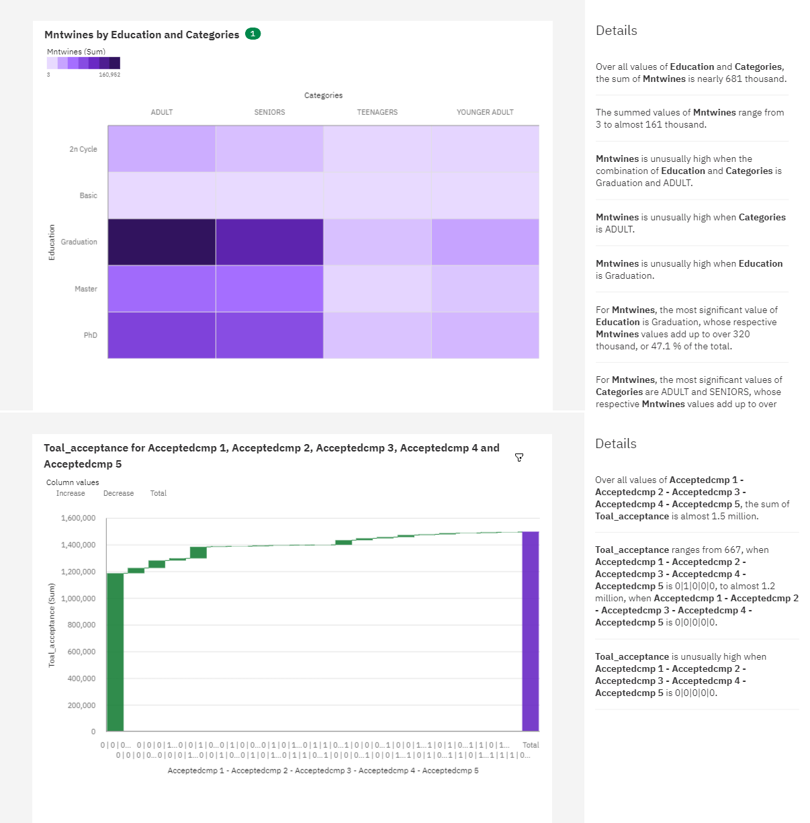

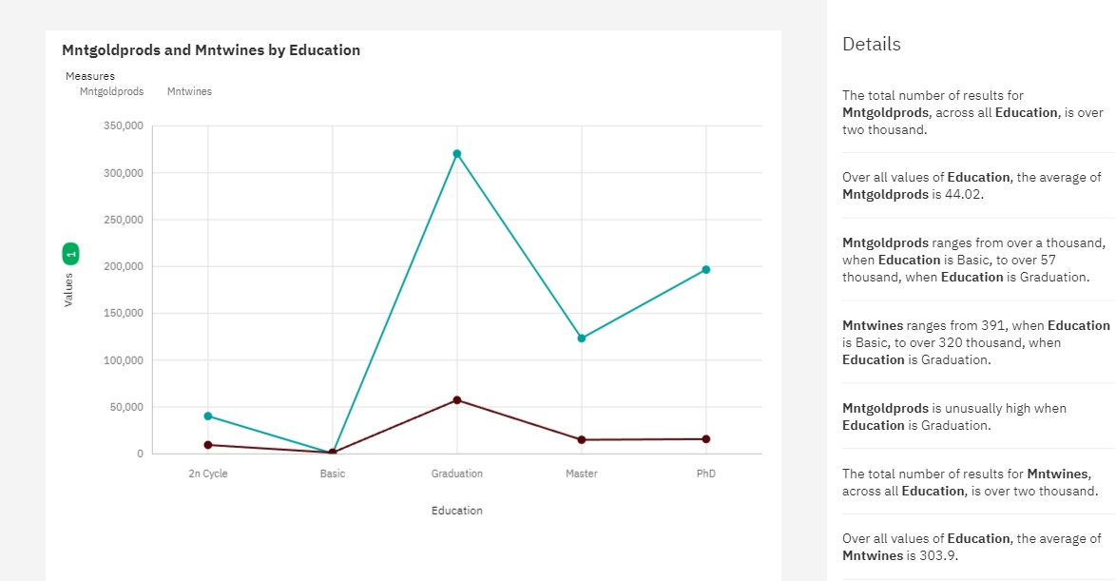

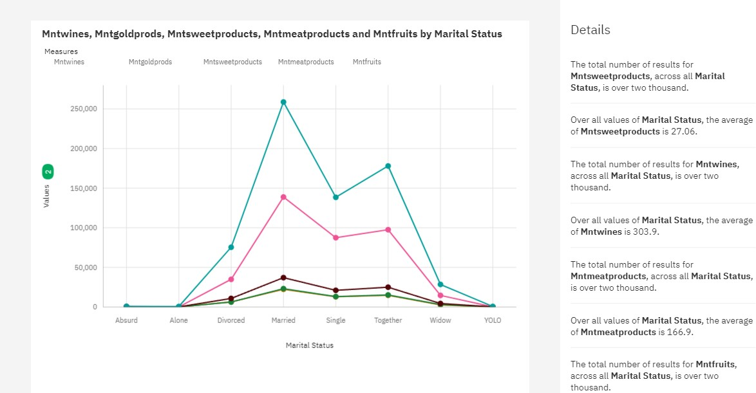

**STORY**

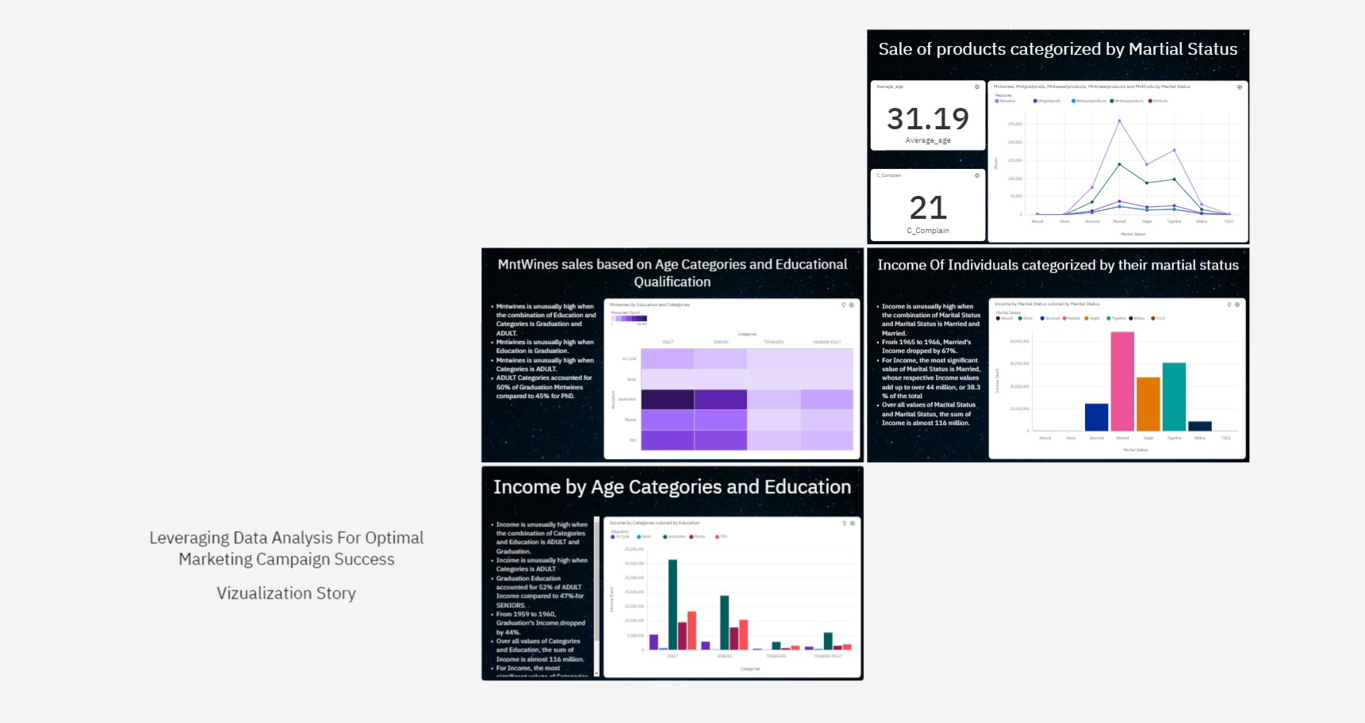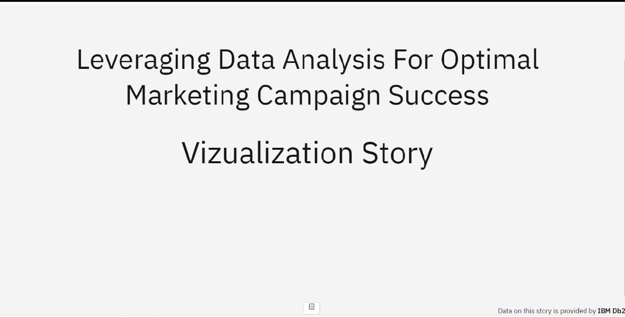

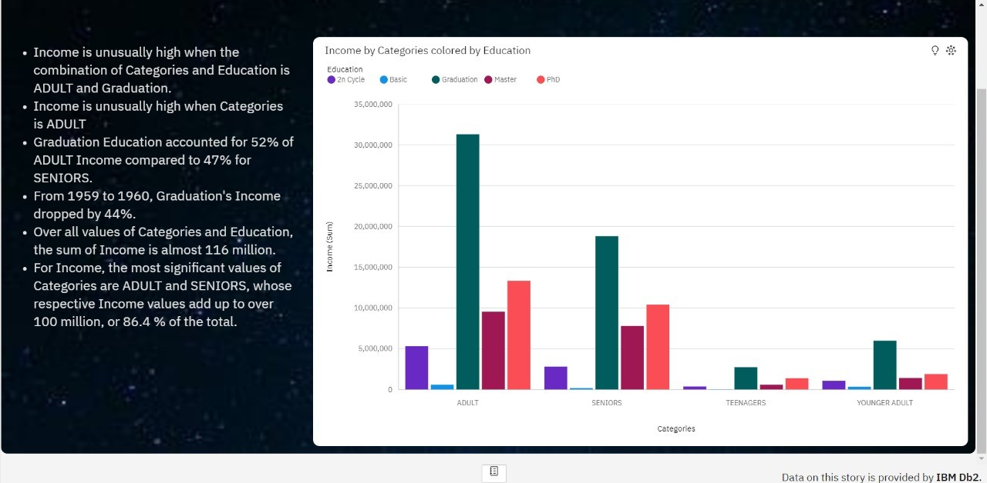

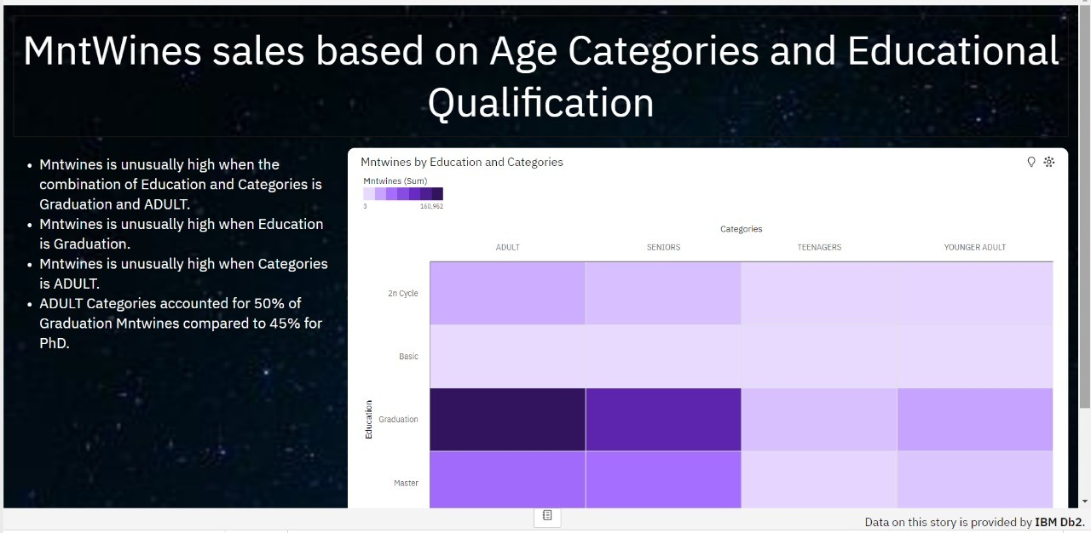

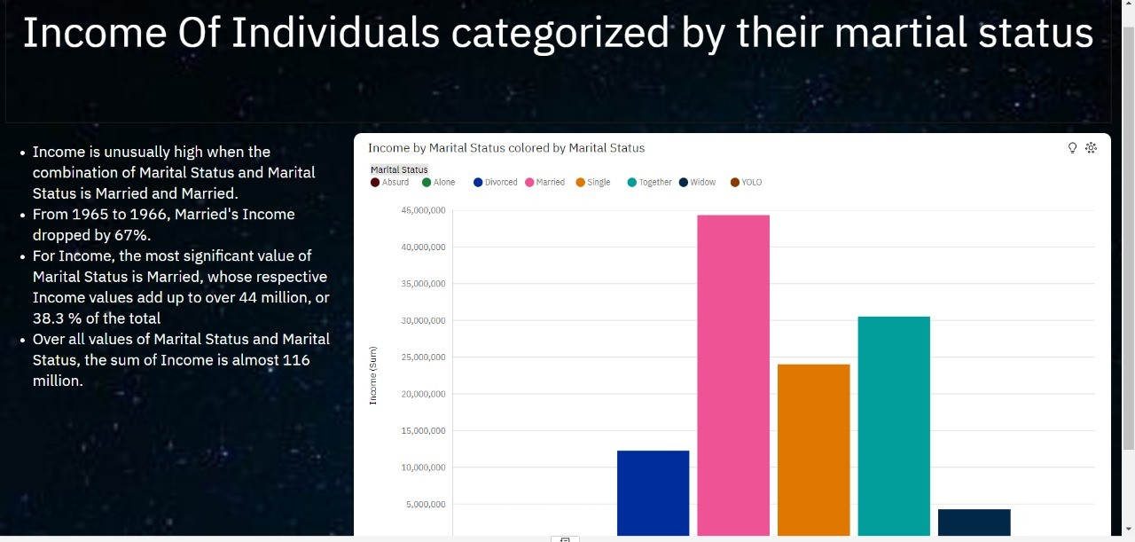

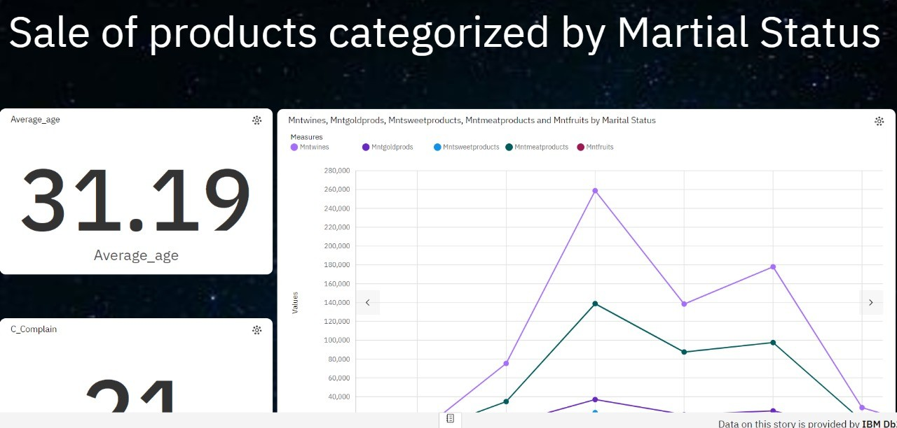

**DASHBOARD:**

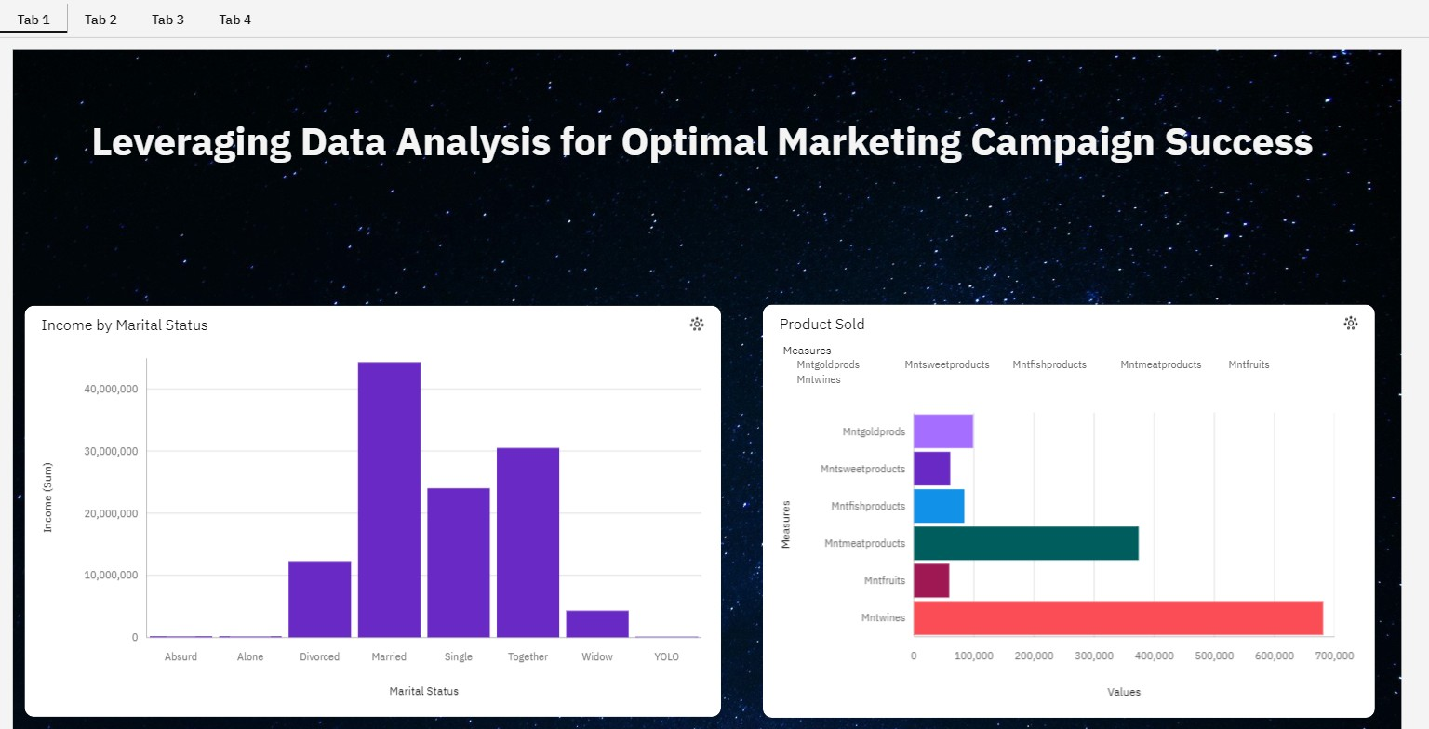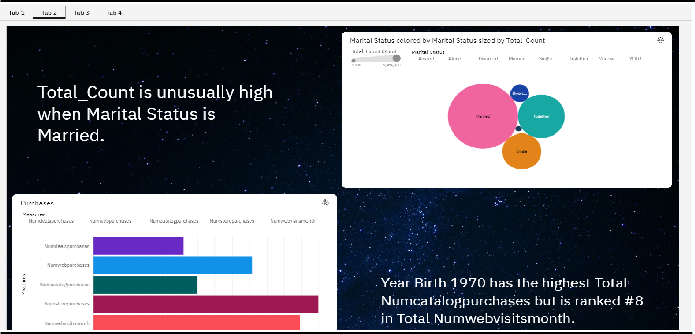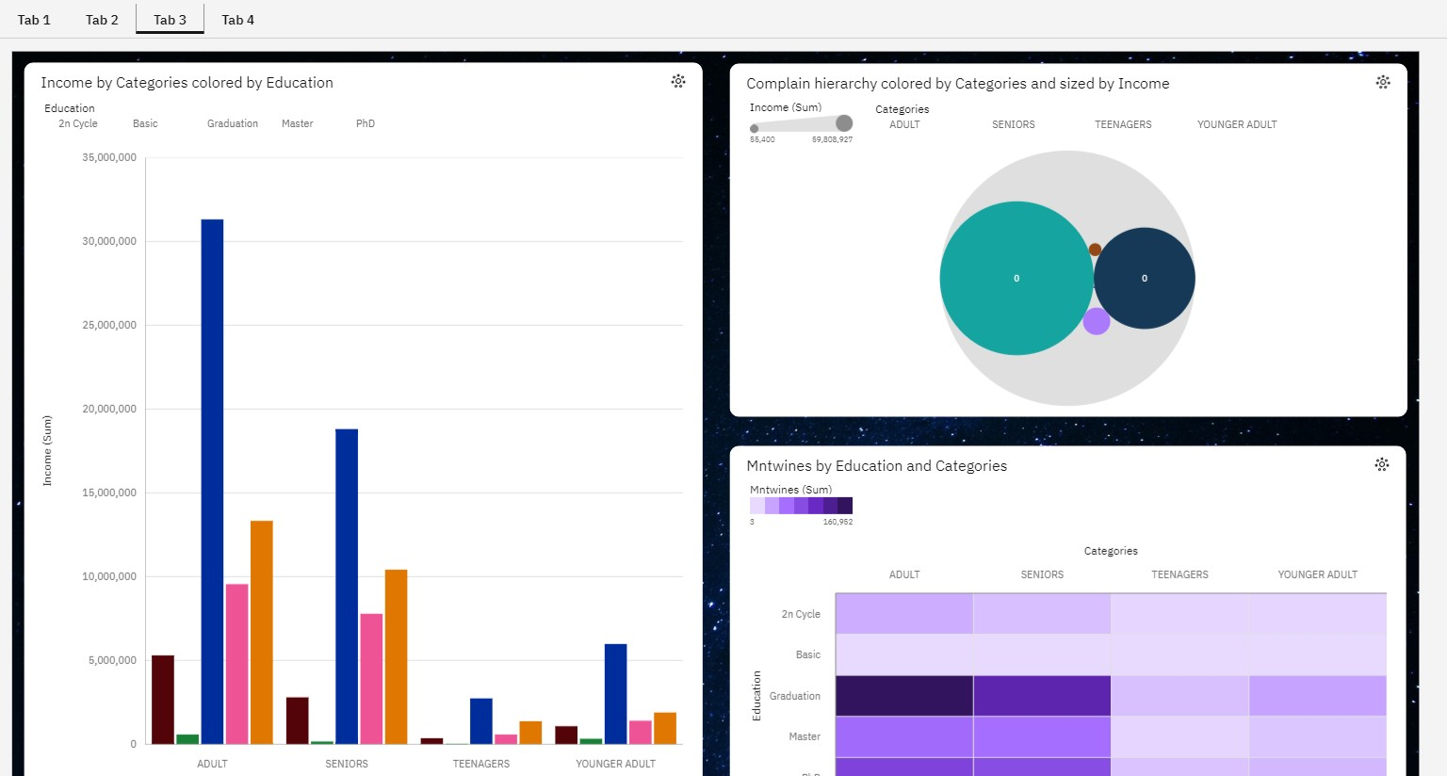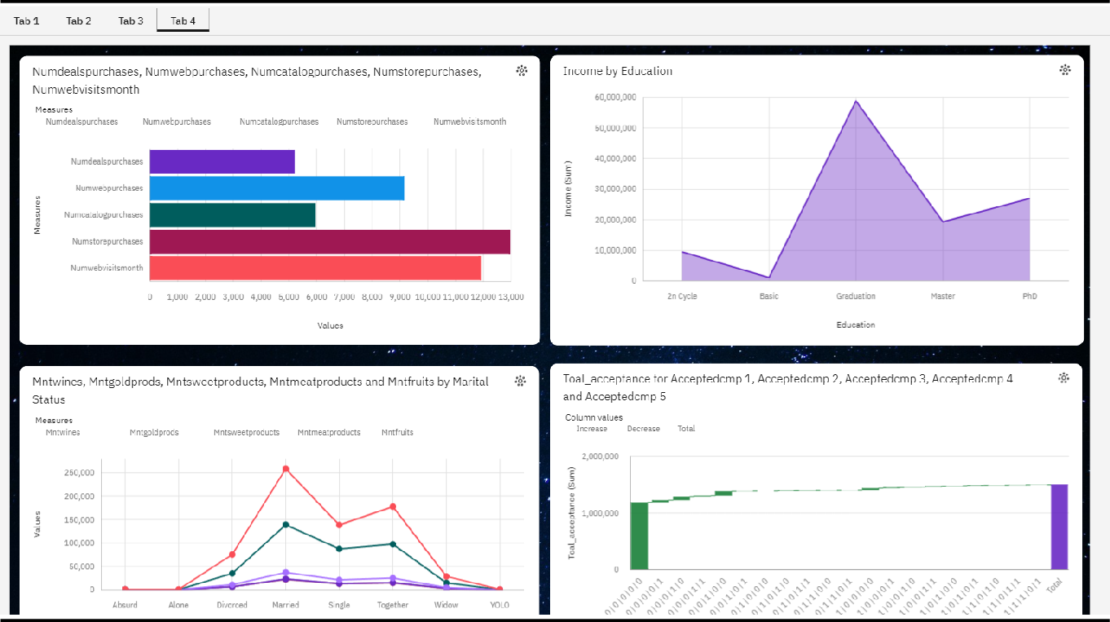

**CHAPTER 10**

## Advantages and Disadvantages Advantages of Using IBM Cognos for Marketing Data Analysis:

1. Comprehensive Data Analysis: IBM Cognos offers a wide range of data analysis tools and features, allowing for comprehensive examination and interpretation of marketing data.
2. User-Friendly Data Visualization: The platform provides user-friendly data visualization and dashboard creation tools, making it easier for marketing professionals to understand and present insights.
3. Integration Capabilities: Cognos supports integration with various data sources, ensuring that all relevant marketing data is accessible for analysis.
4. Real-time Monitoring: Real-time data monitoring features enable marketers to respond promptly to changing market conditions and make data-driven decisions on the fly.
5. Scalability: Cognos can scale to handle larger datasets and increasing data volumes, making it suitable for businesses of varying sizes.
6. Security Measures: The platform includes robust security measures to protect sensitive marketing data and ensure compliance with privacy regulations.

## Disadvantages of Using IBM Cognos for Marketing Data Analysis:

1. Cost: Implementing and maintaining IBM Cognos can be costly, especially for smaller businesses, as it often requires specialized expertise and licensing fees.
2. Learning Curve: Users may face a learning curve when navigating the platform's features, particularly for those new to data analysis and visualization tools.
3. Resource Intensive: Running Cognos effectively may demand substantial hardware and IT resources to support its performance and scalability.
4. Complexity: The extensive range of features can sometimes lead to complexity in setting up and maintaining the platform.
5. Limited Free Version: The full potential of IBM Cognos is often unlocked through premium paid versions, which can be a drawback for businesses with budget constraints.
6. Customization Challenges: Achieving specific customizations and advanced analytics may require additional development and configuration efforts.

It's important to note that the advantages and disadvantages of using IBM Cognos for marketing data analysis may vary depending on the specific needs, resources, and expertise of your organization. Careful consideration is necessary to determine if Cognos aligns with your business goals and budget.

## CHAPTER 11

**Conclusion**

In conclusion, leveraging IBM Cognos for data analysis in marketing campaigns offers a powerful solution to optimize marketing efforts. This robust platform's comprehensive data analysis tools, user- friendly data visualization, and integration capabilities provide marketing professionals with the means to access, interpret, and present critical insights from a variety of data sources. Real-time monitoring ensures agility in responding to changing market conditions, and scalability allows for handling growing data volumes. However, the adoption of Cognos should be considered in light of potential challenges, including costs, a learning curve, and resource requirements. Nevertheless, when implemented effectively, IBM Cognos empowers marketing teams to make data-driven decisions and drive more successful marketing campaigns, ultimately enhancing business outcomes.

## CHAPTER 12

**Future Scope**

The future scope of using IBM Cognos for data analysis in marketing campaigns is promising and holds several opportunities for businesses. As data-driven marketing continues to evolve, Cognos is well-positioned to adapt and cater to emerging trends. AI and machine learning integration can further enhance predictive analytics, allowing marketers to anticipate customer behavior with greater precision. The platform's scalability ensures it can accommodate the increasing volume of data generated in the digital age. Additionally, as data privacy regulations become more stringent, Cognos can play a crucial role in ensuring compliance. The future may also see advancements in data security features. Moreover, with an emphasis on real-time data analysis, Cognos can enable marketing teams to make instant, data-informed decisions to capitalize on rapidly changing market conditions. As businesses increasingly recognize the value of data-driven decision-making in marketing, IBM Cognos is poised to remain a valuable asset for optimizing campaigns and achieving sustainable growth.

## CHAPTER 13

**Appendix**

Web integration is a critical component in harnessing the power of IBM Cognos for marketing data analysis. This section delves into the pivotal role of web integration in accessing, consolidating, and disseminating data from diverse online sources. It emphasizes the integration of data from websites, social media platforms, and web- based applications into the Cognos ecosystem, enabling marketers to gain a holistic view of their digital presence. Furthermore, it highlights the significance of Application Programming Interfaces (APIs) in facilitating seamless data exchange between web services and Cognos for in-depth analysis. The web-based data visualization capabilities of Cognos, allowing interactive dashboards to be embedded in websites or shared via web links, are also showcased. Real-time web monitoring empowers marketers to respond swiftly to changing web dynamics, while mobile- friendly reports ensure that data insights are accessible on-the-go. Lastly, the section underscores the importance of security and user authentication in safeguarding web data and ensuring compliance. Web integration within IBM Cognos not only streamlines data access and analysis but also supports real-time decision-making, making it an indispensable asset in data-driven marketing campaigns.

**Coding:**

**app.py**

from flask import Flask,render_template app = Flask( name )

@app.route('/') def hello_name():

return render_template('index.html') if name == ' main ':

app.run()

**index.html**

<!DOCTYPE html>

<html lang="en">

<head>

<meta charset="UTF-8">

<meta name="viewport" content="width=device-width, initial-scale=1.0">

<link href='https://fonts.googleapis.com/css?family=Montserrat' rel='stylesheet'>

<link href="[https://cdn.jsdelivr.net/npm/bootstrap@5.3.2/dist/css/bootstrap.min.css](https://cdn.jsdelivr.net/npm/bootstrap%405.3.2/dist/css/bootstrap.min.css)" rel="stylesheet" integrity="sha384-

T3c6CoIi6uLrA9TneNEoa7RxnatzjcDSCmG1MXxSR1GAsXEV/Dwwykc2MPK8M2HN" crossorigin="anonymous">

<script src="[https://cdn.jsdelivr.net/npm/bootstrap@5.3.2/dist/js/bootstrap.bundle.min.js](https://cdn.jsdelivr.net/npm/bootstrap%405.3.2/dist/js/bootstrap.bundle.min.js)" integrity="sha384- C6RzsynM9kWDrMNeT87bh95OGNyZPhcTNXj1NW7RuBCsyN/o0jlpcV8Qyq46cDfL" crossorigin="anonymous"></script>

<title>Document</title>

</head>

<style>

body {

font-family: 'Montserrat';font-size: 22px;

}

</style>

<body style="background-repeat: round;background-image: linear-gradient(to right, #000000, #0a0005, #0f000e, #0f0116, #09041e);">

<!-- <nav class="navbar navbar-expand-lg bg-body-tertiary"> -->

<nav class="navbar navbar-dark navbar-expand-lg bg-dark">

<div class="container-fluid">

<button class="navbar-toggler" type="button" data-bs-toggle="collapse" data-bs- target="#navbarNavAltMarkup" aria-controls="navbarNavAltMarkup" aria- expanded="false" aria-label="Toggle navigation">

<span class="navbar-toggler-icon"></span>

</button>

<div class="collapse navbar-collapse" id="navbarNavAltMarkup">

<div class="navbar-nav">

<a class="nav-link active" aria-current="page" href="">Home</a>

<a class="nav-link" href="#exp">Exploration</a>

<a class="nav-link" href="#dash">Dashboard</a>

<a class="nav-link" href="#story">Story</a>

<a class="nav-link" href="#report">Report</a>

</div>

</div>

</div>

</nav>

<br>

<br><br>

<center><h1 class="text-white">Leveraging Data Analysis for Optimal Marketing Campaign Success</h1></center><br><br>

<br><br><br>

<p class="text-white justify-content-center">Leveraging Data Analysis for Optimal marketing Campaign success" The purpose of this project is to explore the application of data analysis in the context of marketing campaigns and demonstrate how it can be leveraged to achieve optimal success. By harnessing the power of data, marketers can go beyond traditional intuition-based strategies and adopt a data-driven approach to create more targeted and personalized campaigns. This project aims to provide insights into various data analysis techniques, tools, and methodologies that can be employed to uncover hidden patterns and trends in marketing data, enabling marketers to make informed decisions and optimize their campaigns for maximum impact.</p>

<br><br><br>

<div style="display: flex; align-items: center;justify-content: center;flex- direction:column">

<h1 class="text-white">Exploration</h1><br>

<iframe id="exp"

src="https://us3.ca.analytics.ibm.com/bi/?perspective=explore&amp;pathRef=.my_folders% 2FNaanMudhalvanexploration&amp;closeWindowOnLastView=true&amp;ui_appbar=false &amp;ui_navbar=false&amp;shareMode=embedded&amp;subView=model0000018b6cc3b ab4_00000004" width="1000" height="700" frameborder="0" gesture="media" allow="encrypted-media" allowfullscreen=""></iframe>

</div>

<div style="display: flex; align-items: center;justify-content: center;flex- direction:column">

<h1 class="text-white">Story</h1><br>

<iframe id="dash"

src="https://us3.ca.analytics.ibm.com/bi/?perspective=story&amp;pathRef=.my_folders%2F NaanMudhalvanStory&amp;closeWindowOnLastView=true&amp;ui_appbar=false&amp;ui

_navbar=false&amp;shareMode=embedded&amp;action=view&amp;sceneId=- 1&amp;sceneTime=0" width="1000" height="700" frameborder="0" gesture="media" allow="encrypted-media" allowfullscreen=""></iframe>

<div style="display: flex; align-items: center;justify-content: center;flex- direction:column">

<h1 class="text-white">Report</h1><br>

<iframe id="report"

src="https://us3.ca.analytics.ibm.com/bi/?pathRef=.my_folders%2FNaanMudhalvanReport &amp;closeWindowOnLastView=true&amp;ui_appbar=false&amp;ui_navbar=false&amp;s hareMode=embedded&amp;action=run&amp;format=HTML&amp;prompt=false" width="1000" height="700" frameborder="0" gesture="media" allow="encrypted-media" allowfullscreen=""></iframe>

</div>

<div style="display: flex; align-items: center;justify-content: center;flex- direction:column">

<h1 class="text-white">Dashboard</h1><br>

<iframe id="story"

src="https://us3.ca.analytics.ibm.com/bi/?perspective=dashboard&amp;pathRef=.my_folder s%2FNaanMudhalvanDashboard&amp;closeWindowOnLastView=true&amp;ui_appbar=fal se&amp;ui_navbar=false&amp;shareMode=embedded&amp;action=view&amp;mode=dash board&amp;subView=model0000018b6cf6e6cf_00000003" width="1000" height="700" frameborder="0" gesture="media" allow="encrypted-media" allowfullscreen=""></iframe>

</div>

</body>

</html>

**SCREENSHOTS:**

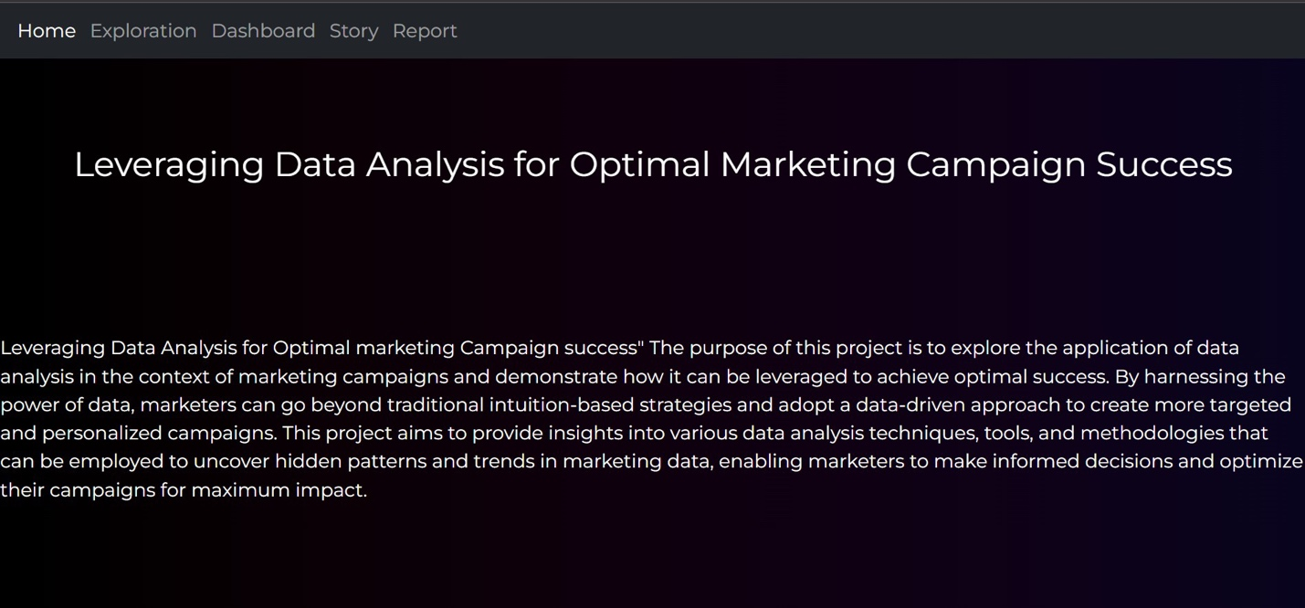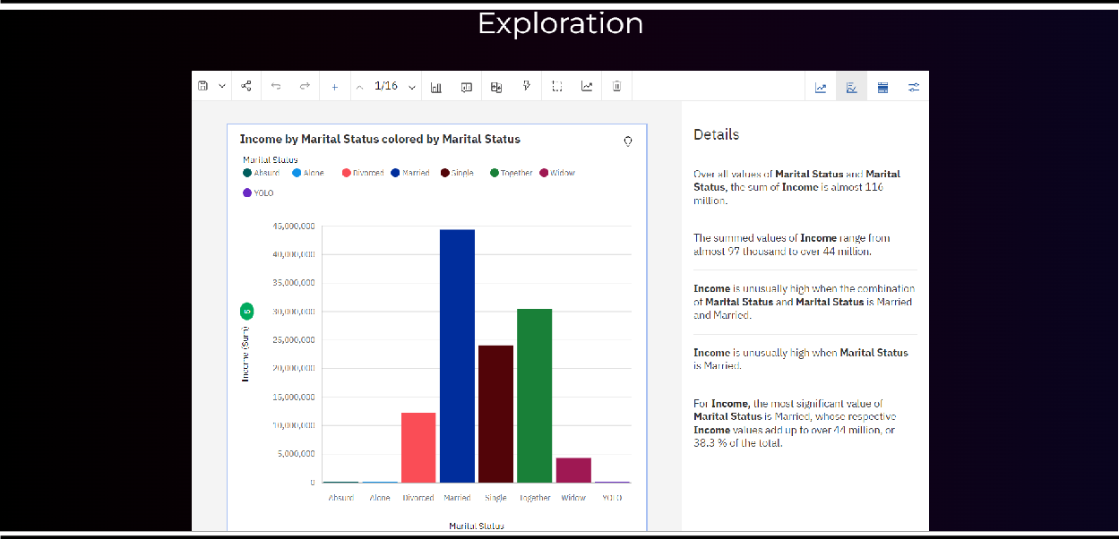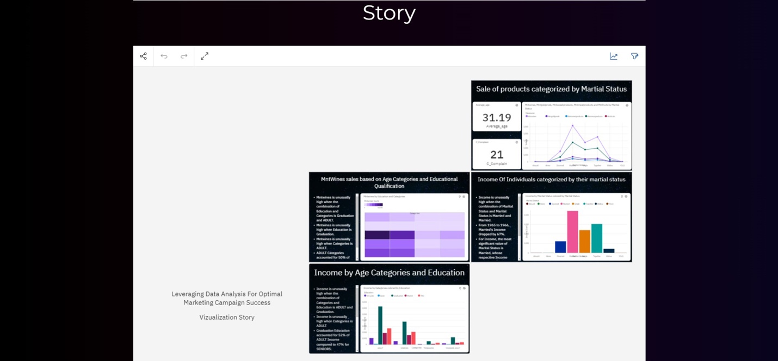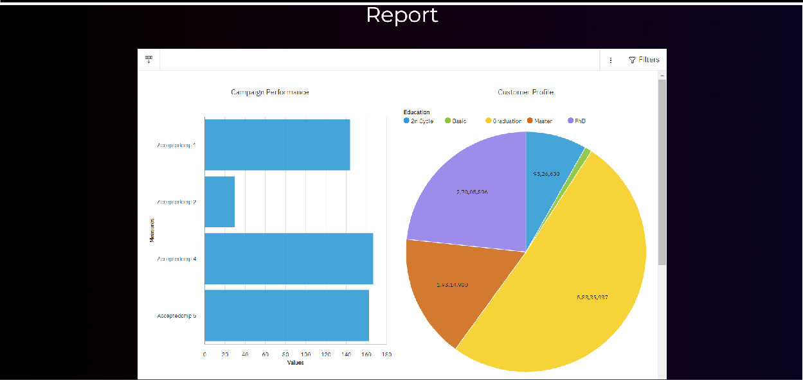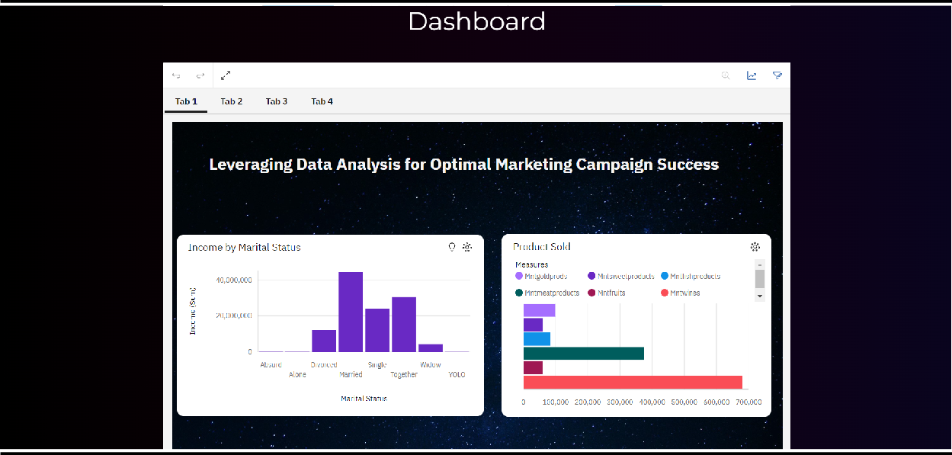

**GITHUB LINK:**

https://github.com/teejay0190/naan-mudhalvan

**VIDEO LINK:**

https://drive.google.com/file/d/1dte_QfMue43UckhoTwRW2pHZhhQZ4HpZ/view

?usp=sharing